Identification of Incomplete Penetration Welding Defects on Digital Radiographic Film Figures with the Geometric Invariant Moment
Agus Probo Sutejo¹*, Haerul Ahmadi², Tasih Mulyono³
1, 2, 3) Sekolah Tinggi Teknologi Nuklir, Yogyakarta, Indonesia
*Corresponding Email: agusprobos21@gmail.com
ABSTRACT
IDENTIFICATION OF INCOMPLETE PENETRATION WELDING DEFECTS ON DIGITAL RADIOGRAPHIC FILM FIGURES WITH THE GEOMETRIC INVARIANT MOMENT. The examination of defects in radiographic films necessitates specialized knowledge, as indicated by an expert radiographer (AR) degree, yet the subjectivity of AR in identifying defects is problematic. To overcome this subjectivity, an automatic welding defect identification is needed. This is executed by using Matlab to create artificial neural networks, which is beneficial for users with the graphical user interface (GUI) feature. One of the breakthroughs in the figure extraction into seven feature vector values is the geometric invariant moment theory. This prevents translation, rotation, and scaling from changing the figure's characteristics. Therefore, a welding defect identification system with a geometric invariant moment was created in the digital radiographic film figure to overcome the reading error by AR. The identification system obtained an accuracy rating of 89.9%.
Keywords: Penetration, welding defects, digital radiographic film, geometric invariant
INTRODUCTION
The development of radiographic tests from conventional to digital offers several benefits. Digital radiography employs a reusable filmless detector plate, which eliminates the need for conventional films. The radiographic test results are also processed using the computer, therefore, this test avoids the use of chemicals for film processing. Besides, unlike conventional films, the results in the form of digital figures may be preserved for years without deterioration in quality [1].
Recent technological developments, such as in computer systems, allow data processing into information that can be stored, printed, and others. One example of such data is in the form of figure or digital radiographic figure, which a computer system may analyze to acquire better and more efficient information [2]. A welding flaw on a digital radiography film figure can be detected by the computer by extracting characteristics from the pattern of defects to be found. These characteristics are then analyzed by a computing system [3].
Hu in 1962 introduced one theory for extracting features from figures by using Invariant Moment. The figure object characteristics are unaffected by rotation, scale, and translation (RST-Invariant), while the object figure is classified as a numerical feature [4].
In this invariant feature, the Geometric Invariant Moment (GIM) theory defines figure of a grayscale object in the form of seven vector values [5]. Each object's figure is defined by these seven vector values. These characteristics are unchangeable and as a result, the RST-Invariant can be used to identify defects on digital radiographic films. The advantage of this method over others is that figure characteristics are not affected by translation, rotation, and scale changes.
The purpose of this study is to develop a system that can detect Incomplete Penetration (IP) and Clustered Porosity (CP) welding defects in digital radiographic film figures using GIM. The identification system is built with Matrix Laboratory (Matlab) and a backpropagation pattern recognition neural network.
Method
Sampling was performed by exposing existing samples to artificial defects without modification. The previous stage produced a digital radiographic film figure in .bmp format and was opened before being converted into grayscale. After obtaining the grayscale figure, the cut point was calculated as desired. Furthermore, the intersection point was manually calculated by assigning a point to figure opened using Matlab. At this stage, over 6670 figures fragments were obtained, with 5998 figures showing IP defects and 672 indicating CP defects.
The GIM theory was then used to extract the features from the cut figures with each having 7 feature vector values. The Invariant Moment value in all extracted figures was then automatically saved in .mat format with the name of the game feature and contained a workspace with the variable name allval. This allval is the figure feature vector value that has been extracted and compiled from 6670 figures with a 7 x 6670 matrix. The result was saved automatically with the name Cirigim.mat with the variable allval.
The resulting figure feature data was used to produce an artificial neural network. Based on the sequence of figures that have been cut and the features extracted, the data was labeled according to the defect indication. From the 1st to the 5998th figure, IP defects indications were labeled 1. The CP defect indications were labeled 2 starting from the 5999th to the 6670th figures. After this, the data were divided into training data (trainset) and test data (testset). This division was performed using the kfold cross-validation method by randomly dividing the data into k parts for use as trainset and testset. In this study, the value of k=4 was used as cross-validation.
After obtaining the distribution of the figure feature dataset using kfold cross-validation, an artificial neural network classification model was then developed. In the Matlab application, a feature allows the creation of an artificial neural network, which in this study used a backpropagation pattern recognition classification model.

Results and Discussion
Results of Data Collection
The results of data collection were used as input in making the identification system. Moreover, this figure data was taken from the exposure of the test object and standard material made of stainless steel. On standard stainless steel material, exposure was performed to obtain a digital radiographic film figure with a grayscale scale between 7000 to 8000 in the form of a digital radiographic film. The exposed figure was then selected to obtain a figure that indicated IP and CP defects. Furthermore, this classification was accomplished by the interpretation of digital radiography films. The IP defects were indicated by insufficient filling of the root part where one or both parts were not fused [6]. Visually, digital radiography film was distinguished by a darker figure in the center of some or all of the weld. Meanwhile, CP defects are indicated by cavities that were close together and form randomly distributed clusters [6]. In terms of figure, digital radiography films were distinguished by black circle figures that clustered in certain areas in the weld.
To retrieve the area of interest on the part of the weld with indications of IP and CP defects, the classified figure was then cut to a size of 170 x 85 pixels. Based on exposure data collection on the DR device, 503 digital radiographic figures were obtained and cut to the desired size. According to the indication of visible defects, the cropped point was manually determined by clicking on the midpoint of the indicated weld area and by interpretation using the Matlab. Using Matlab, 503 figures were opened and cropped one by one after the other. According to the results of figure cutting, there are 5998 figures with indications of IP defects and 672 figures with indications of CP defects. Figure 1 shows an example of the consequences of cutting a digital radiography film figure.
Figure 1 part (a) shows an indication of IP defects. This was indicated by a darker part in the weld area on the radiographic digital film. IP occurs once the root part is not filled by the weld adequately [7]. Figure 1 part (b) shows an indication of the CP defect. This was indicated by the black dot that clusters in more than 4 in the weld area on the radiographic digital film, and this was an indication of group porosity [7].

(a) | (b)
Figure 1. The result of cutting a digital radiographic film figure with an indication of a defect
- Incomplete Penetration and (b) Clustered Porosity

Manufacturing Result of identification System
The GUI Matlab was used to produce the welding defect identification system on digital radiography film. In Matlab, GUI or graphical user interface is a display designed to assist others in executing certain applications. It is contained in two files, namely .fig format which holds graphic layout information, and an m-file in .m format, containing the main GUI functions and several subfunctions[8]. Figure 2 depicts figure representation of the GUI created for this identification system.
Figure 2 shows an initial view of the welding defect identification system with geometric invariant moment on a digital radiographic film figure that was produced. The identification process began by first opening the digital radiographic film figure then cutting it apart. Subsequently, these features were extracted and identified based on the characteristics.

Results of Identification System Test
In this study, an identification system was developed for defects indications contained in digital radiographic film figures. From the results, sample figures were classified into two defects indications, namely IP and CP. Also, this identification system test was focused on the artificial neural network classification model produced in the network training process.
In the training, there were 3 layers, generated in the artificial neural network classification model namely input, hidden, and output layers. The input layer consisted of 7 invariant moment features from figure feature extraction using the GIM method. Meanwhile, to determine the relationship between input and output, a hidden layer is constructed automatically. It is generated by training the artificial neural network using Matlab. The hidden layer contained up to 150 neurons that are connected to one another. Furthermore, the output layer consisted of 2 outputs, namely defects indications such as IP and CP. Figure 3 depicts the configuration of this artificial neural network classification model.
To report the raw results of the classification experiments, the classification model was tested using a confusion matrix, which is a 2D array of size K × K (where K is the total number of classes) [9]. This method calculates the accuracy of the self-created artificial neural network classification model. Moreover, it reveals the amount of data used to minimize calculation errors.
Kfold cross-validation is a resampling procedure to evaluate a classification model in a machine learning problem with a limited sample. This approach randomly divides the data set into k parts, or groups, of approximately similar size. The first group was classified as validation data, while the rest as training data [10].
Option k is commonly 5 or 10, but there is no formal rule. The size difference between the training set and the sample re-set becomes smaller, as k increases. Meanwhile, as this difference decreases, the engineering bias reduces. In this situation, the difference between the estimated and the true value of performance is known as bias [11].

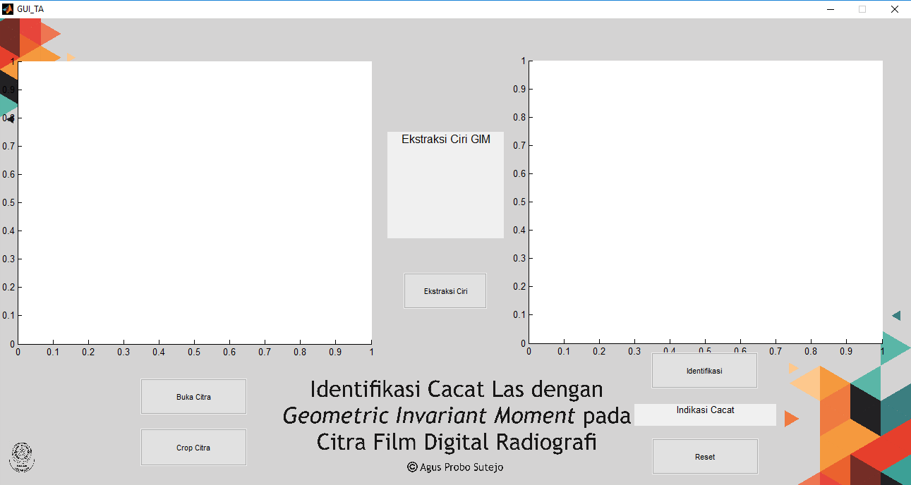
Figure 2. GUI Identification System

Figure 3. Konfigurasi Model JST

The data was divided into 4 parts, 1 was test data and the other 3 were training data. Each part has the opportunity to become test data because this was repeated 4 times. Figure 4 shows the division below:

Figure 4 Kfolds Cross-Validation

The white box is the training data and the shaded box is the test data. Figure 5 displays the test findings in the form of a confusion matrix as follows:
Figure 5. Confusion Matrix Kfolds with (a) k=1; (b) k=2; (c) k=3; (d) k=4
Figure 5 displays the result of testing an artificial neural network model with a confusion matrix and k repetition. According to this test, the accuracy value for k = 1 was 91.9%, k = 2 was 89.9%, k = 3 was 91.7%, and k = 4 was 89.9%. According to the pessimistic approach, which uses the smallest accuracy value, the identification system obtained an accuracy of 89.9%.
The backpropagation pattern recognition artificial neural network classification model, which was applied to digital radiography films using the invariant moment method, achieved an accuracy rate of 89.9%. There was a significant difference to the study conducted [12] which used the same method to classify the roughness level of the lathe process and generated an accuracy rate of 29.4%. Furthermore, this study showed similar results with [13] which used the first invariant moment to detect coconut objects with an accuracy of 90%. This accuracy showed that the method used to classify artificial neural networks in this study, namely GIM, was more appropriate for identifying defects types or certain objects compared to the roughness level from the machining process.
Furthermore, the study was successful in making an identification system for applications in the digital radiography field. This system only identifies defects with IP and CP. Using the Matlab GUI, the system was successfully created and easy to use. Figure patterns can be recognized and identified, and the GUI, as an interface, facilitates the use of this identification system.
Since the system developed was only limited to defects with IP and CP, further developments are needed for other indications of defects. This system is only able to identify one indication of defects in figure. Moreover, it was for reading defects and not for recording the identification results. The interface system could only read figures one at a time by resetting each figure change.

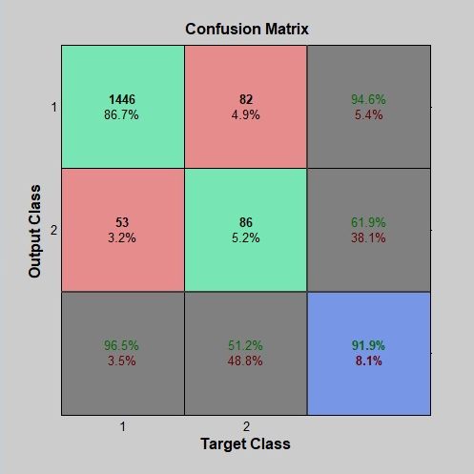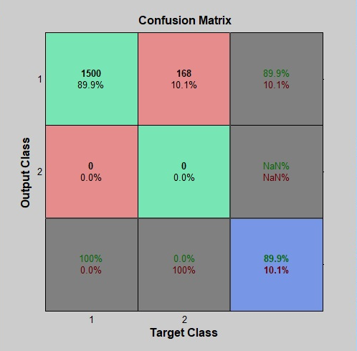
(a) | (b)
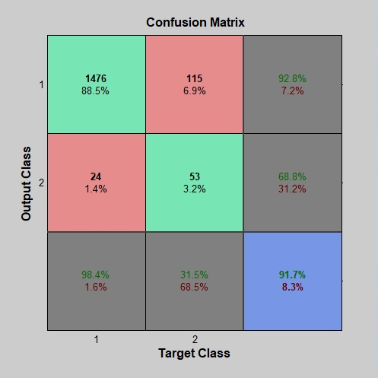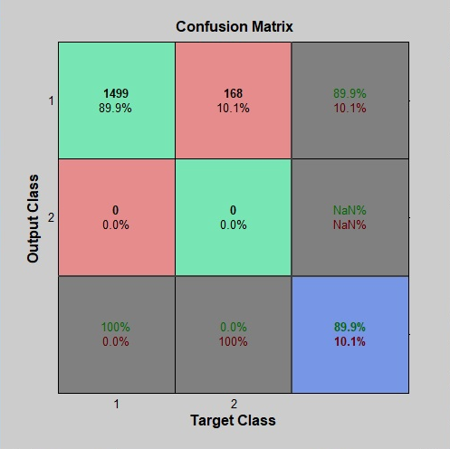
(c) | (d)
Figure 5. Confusion Matrix Kfolds with (a) k=1; (b) k=2; (c) k=3; (d) k=4

CONCLUSION
Based on the results and discussion, this study was successful in welding defect identification systems with GIM. This was conducted on radiographic digital film figures capable of identifying defects with IP and CP. Furthermore, this system is made using Matlab R2013a with the GUI feature. The identification system was made by training artificial neural networks, and the backpropagation pattern recognition classification model achieved an accuracy rate of 89.9%.
REFERENCES
- T. Kersting, N. Schönartz, L. Oesterlein, and A. Liessem, “High end inspection by filmless radiography on LSAW large diameter pipes,” NDT E Int., vol. 43, no. 3, pp. 206–209, Apr. 2010, doi: 10.1016/j.ndteint.2009.11.004.
- Hilmi Trian Setyawan and Suryono, “Uji Resolusi Spasial Pada Perangkat Lunak Computed Radiography Menggunakan Pengolahan Citra Digital,” Youngster Phys. J., vol. 3, pp. 311–316, Oct. 2014.
- Muhtadan, “Ekstraksi Ciri Cacat Pengelasan Pada Citra Digital Film Radiografi Menggunakan Geometric Invariant Moment Dan Statistical Texture,” J. Forum Nukl., vol. 3, no. 2, pp. 83–106, Nov. 2009.
- Ming-Kuei Hu, “Visual pattern recognition by moment invariants,” IRE Trans. Inf. Theory, vol. 8, no. 2, pp. 179–187, Feb. 1962.
- D. Žunić and J. Žunić, “Shape ellipticity from Hu moment invariants,” Appl. Math. Comput., vol. 226, pp. 406–414, Jan. 2014.
- Pusdiklat-BATAN, “Sumber Radiasi dan Peralatan Radiografi,” 2016.
- R. L. Timings, Fabrication and welding engineering. London[u.a.: Routledge, 2011.
- C. S. Lent, Learning to program with MATLAB: building GUI tools. Hoboken, NJ: Wiley, 2013.
- O. Marques, Practical Image and Video Processing Using MATLAB®: Marques/Practical Image Processing. Hoboken, NJ, USA: John Wiley & Sons, Inc., 2011.
- G. James, D. Witten, T. Hastie, and R. Tibshirani, An Introduction to Statistical Learning, vol. 103. New York, NY: Springer New York, 2013.
- M. Kuhn and K. Johnson, Applied Predictive Modeling. New York, NY: Springer New York, 2013.
- M. F. Achyar, “Pengembangan Sistem Identifikasi Tingkat Kekasaran Permukaan Pada Hasil Proses Mesin Bubut Berbasis Citra Mikroskopis,” STTN-BATAN, 2019.
- Rizon, M., Haniza, Y., Puteh, S., Yeon, A., Shakaff, M., Abdul Rahman, S., and Karthigayan, M., “Object Detection using Geometric Invariant Moment,” p. 3, 2006.

