DEVELOPMENT OF 5 DOF ROBOTIC ARM PROTOTYPE CONTROL SYSTEM IN BRACHYTHERAPY PREPARATION BASED ON ARTIFICIAL NEURAL NETWORK
Adi Abimanyu, M. Eng ^{1*}, Misbah Habib Putra², Dr. Muhtadan, M.Eng³
1,2,3) Sekolah Tinggi Teknologi Nuklir,Yogyakarta, Indonesia
*Corresponding email: abimanyu.avr@gmail.com
ABSTRAK
PENGEMBANGAN SISTEM KENDALI PROTOTIPE LENGAN ROBOT 5 DOF PADA PREPARASI BRACHYTHERAPY BERBASIS JARINGAN SARAF TIRUAN. Brachytherapy merupakan pengobatan kanker menggunakan sumber radioaktif secara implantasi sementara atau tetap pada jaringan yang terjangkit kanker. Brachytherapy menggunakan sumber radioaktif Ir-192 yang terbungkus dalam kapsul stainless steel yang memiliki ukuran diameter 0,5 mm serta panjang 4 mm. Pusat Teknologi Radioisotop dan Radiofarmaka dalam melakukan preparasi mikrokapsul menggunakan telemanipulator yang berpengaruh pada ketelitian serta bahaya radiasi yang diterima operator. Solusi permasalahan tersebut, maka perlu dirancang lengan robot 5 DoF berbasis jaringan saraf tiruan sebagai alat bantu pemindahan sumber radioaktif sehingga meningkatkan akurasi serta keamanan operator dalam preparasi sumber radioaktif. Pada pengembangan sistem kendali lengan robot 5 DoF ini menggunakan NImyRIO yang dapat mengoperasikan motor servo, relay pump dan valve realese, pengolahan citra serta inverse kinematic. Pada inverse kinematic menggunakan metode jaringan saraf tiruan dengan validasi forward kinematic. Hasil dari pengujian inverse kinematic didapatkan nilai RMSE 2,78932 untuk $x$, 5,05205 untuk $y$ dan 12,641 untuk $z$ pada pengujian inverse kinematic jaringan saraf tiruan. Sehingga akurasi inverse kinematic jaringan saraf tiruan perlu dikembangkan kembali.
Kata kunci: Brachytherapy, Lengan Robot, Inverse Kinematic, Jaringan Saraf Tiruan
ABSTRACT
DEVELOPMENT OF 5 DOF ROBOTIC ARM PROTOTYPE CONTROL SYSTEM IN BRACHYTHERAPY PREPARATION BASED ON ARTIFICIAL NEURAL NETWORK. Brachytherapy is a cancer treatment that uses radioactive sources with temporary or permanent implantation in cancer tissue. The theraphy uses a radioactive Ir-192 source wrapped in a stainless steel capsule with a diameter of 0.5 mm and a length of 4 mm. The Center for Radioisotopes and Radiopharmaceutical Technology applies a remote manipulator to manufacture microcapsules, which affects the accuracy and risks of the radiation received by the operator. Therefore, to solve this problem, it is necessary to design a 5 DoF robotic arm based on artificial neural networks as a radioactive source transfer tool to improve the precision and safety of operators in preparing the radioactive sources. In developing the 5 DoF robotic arm control system, the NImyRIO was employed, which can control the servo motor, relay pump and valve reality, image processing, and inverse kinematic. The inverse kinematic uses the neural network method with a forward kinematic validation. The inverse kinematic test obtains the RMSE value of 2.78932 for x, 5.05205 for y, and 12.641 for z in the inverse kinematic test of artificial neural networks. Therefore, the inverse kinematic accuracy of the artificial neural network needs to be redeveloped.
Keywords: Brachytherapy, Robotic Arm, Inverse Kinematic, Artificial Neural Network
INTRODUCTION
Diseases are health disorders caused by viruses, bacteria, and abnormalities in human organs. One of the most dangerous diseases in the world is cancer, the abnormal growth of cells in body tissues that undergo mutations and changes in biochemical structure [1]. Radiation therapy is currently the most effective treatment for killing cancer cells. Out of the 10.9 million people diagnosed with cancer each year, about 50% require radiotherapy, and 60% receive curative treatment [2]. Brachytherapy is a radiotherapy method that uses the radioactive substance Ir-192 by bringing the substance closer to the organs or tissues affected by cancer cells. The radioactive material is enclosed in a capsule with a micro size.
In Indonesia, the National Nuclear Energy Agency (BATAN) is an institution that conducts research, development, and utilization of nuclear technology. One unit studying radioisotopes as an application in brachytherapy is the Center for Radioisotope and Radiopharmaceutical Technology (PTRR). In this case, PTRR has the right to manufacture microcapsules from radioactive material Ir-192, which has a diameter of 0.3 mm and a length of 3 mm [3]. The PTRR microcapsules are assembled in a host cell to reduce the operator's radiation exposure and use a remote manual manipulator. Therefore, it requires special expert knowledge of the operator to assemble these microcapsules.
The automation of all fields and connectivity are real signs of the era of the industrial revolution 4.0. One of the unique and special signs of industrial revolution 4.0 is the many possible applications of artificial intelligence (AI) [4]. The innovation in the development of the telemanipulator is the use of robotic arm technology. The robotic arm can function like a human arm with high precision and accuracy. The robotic arm consists of three parts: the mechanical structure, the drive, and the control system [5]. In the mechanical structure, the robotic arm must have radiation resistance. For the drive and control system, the robot arm can execute movements as requested by the operator.
Research conducted by [6] resulted in a control system with forward kinematic movement. Forward kinematic is a movement by changing the angle variable at the joint of the robotic arm to get the position and orientation of the end-effector. Such movement causes new problems in determining the angle at each joint on the robotic arm when the point of the end-effector is known. Therefore, there is a need to develop 5 degrees of freedom (DoF) robotic arm that can move inverse kinematically. The calculation of the inverse kinematic is more complex than that of the forward kinematic. This is because the calculation of inverse kinematic is to find the angle of each joint based on the final position and orientation of a robot. The solution of inverse kinematic can be carried out using two methods, such as geometric and numerical approaches. These two approaches require a computer device to perform calculations repeatedly to obtain an inverse kinematic solution; hence this research is proposed to use an artificial neural network (ANN).

Method
Research Implementation
The research on the development of the control system on the 5 DoF robotic arm uses several stages, as shown in Figure 1. The stages include:
- Literature study
- System requirements analysis
- Integration of system components in electronic circuits
- Robotic arm control algorithm design
- Robotic arm control program design
- Implementation of electronic circuits and software to robotic arms
- Robotic arm test
- Data collection
- Data analysis
- Report generation

Literature Study
The brachytherapy preparation process uses a source of iridium-192, which is included in a capsule. The field review obtains the size of iridium-192 and the capsule, as shown in Figure 2. In this iridium-192 preparation process, the robotic arm carries out transferring iridium-192 from the hot cell conveyor into a new microcapsule then weld the microcapsules. The microcapsule results are shown in Figure 3.

System requirements analysis
System requirements analysis is carried out to determine the components needed to design the 5 DoF robotic arm control system. Therefore, the 5 DoF robotic arm control system for brachytherapy preparation requires components, as shown in Table 1.

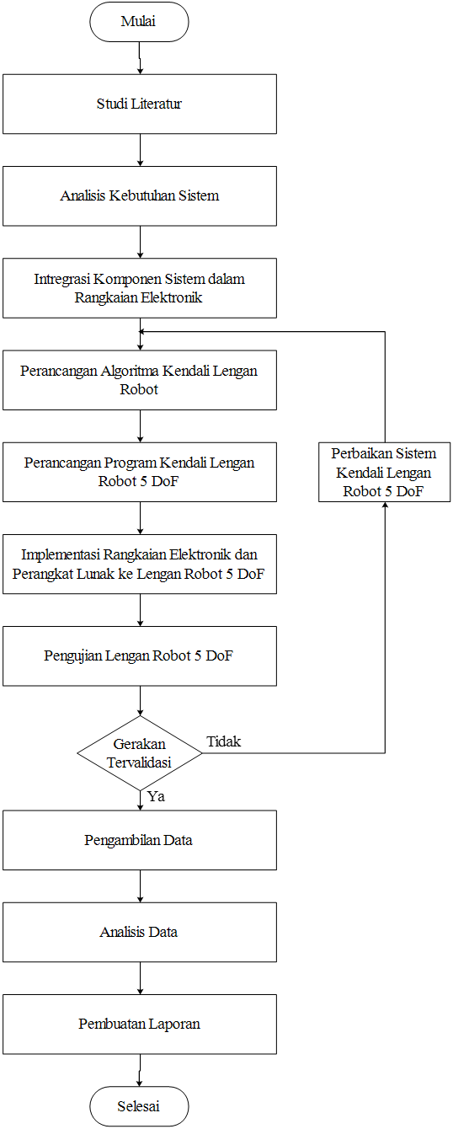
Figure 1. Flowchart of research steps

Integration of System components in Electronic Circuits
The integration of components in electronic circuits corresponds to the system requirements analysis. Therefore, when integrating components, it is necessary to know the component input or output used for the NI myRIO 1900, as shown in Figure 3 below.
Figure 2. Dimensions of iridium-192
Table 1. Control system requirements
No | Component | Component position | Function
1 | Personal Computer | Control system | Interface with microcontroller
2 | Power Supply | Control system box panel | Voltage source on NI myRIO 1900
3 | NI myRIO 1900 | Control system | I/O Controller
4 | Servo Motor (1) | Robotic arm | Joint drive 0
5 | Servo Motor (2) | Robotic arm | Joint drive 1
6 | Servo Motor (3) | Robotic arm | Joint drive 2
7 | Servo Motor (4) | Robotic arm | Joint drive 3
8 | Servo Motor (5) | Robotic arm | End-effector drive
9 | Camera | Above the center conveyor | As a digital image sensor in microcapsule positioning
10 | Suction Pump | End of Robotic effector arm | As an end-effector in charge of taking microcapsules
11 | Relay | Control system box panel | As an electrical switch on Valve Release
12 | Valve Release | Control system box panel | As an air release on the pump

5 DoF Robotic Arm Control Algorithm Design
In Figure 4, the robotic arm has to reach several basic positions, such as home (A), Cup (B), and chuck (C). Home is the safe position of the 5 DoF robotic arm, and Cup is a container with microcapsules picked up by the robotic arm. Furthermore, the 5 DoF robotic arm leads to the chuck as the microcapsules for welding. When positioning, the home is a balanced position of the 5 DoF robotic arm; hence it does not burden the servo motor continuously. On the other hand, the Cup is on the conveyor belt with many changes in position due to the manual movement of the remote manipulator, which is still within the scope of the conveyor area. Therefore, the position of the Cup is determined using image processing. Meanwhile, the chuck is the constant position of the microcapsule welding machine. Hence, the movement of the 5 DoF robotic arm can be shown in Figure 5.

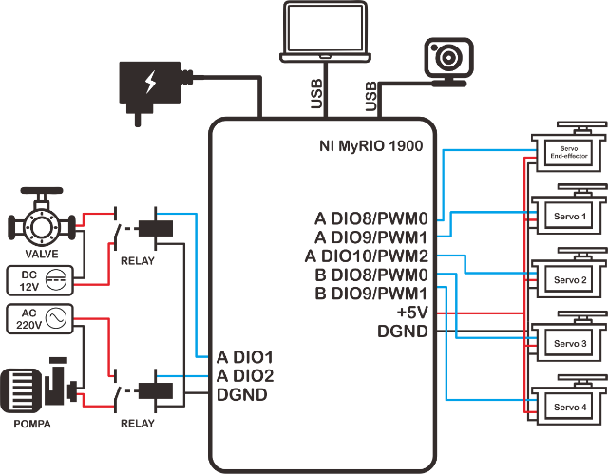
Figure 3. I/O circuit of NImyRIO 1900

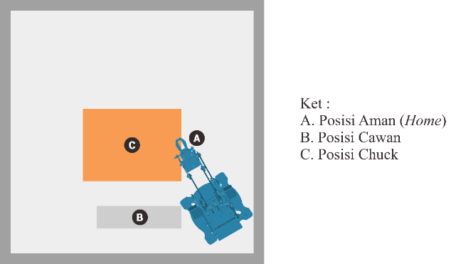
Figure 4. Robotic Arm reach position

5 DoF Robotic Arm Test
The 5 DoF robotic arm control system performs several tests. The image processing test tests the Cup position based on the image processing. The kinematic test of the robotic arm uses forward kinematic as a comparative analysis with inverse kinematic and motion test of the servo motor. Furthermore, a repeatability test is also carried out on the 5 DoF robotic arm with the same input, in which the robotic arm can provide the same position.

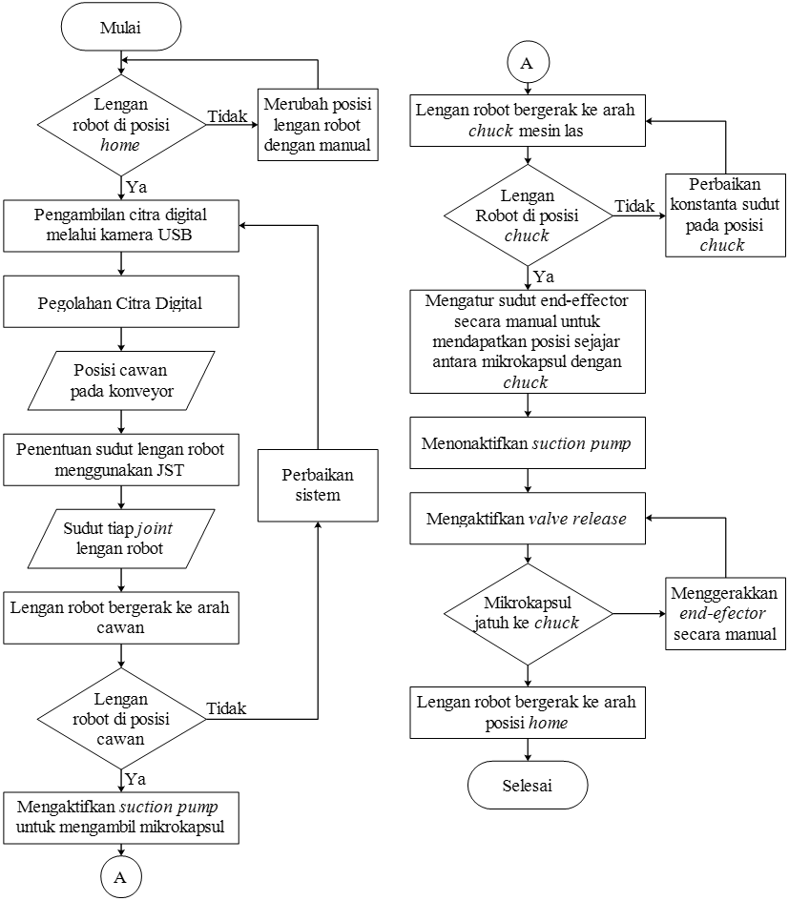
Figure 5. Algorithm design flowchart
Results and Discussion
5 DoF Robotic Arm Control System Software and Hardware
Developing a 5 DoF robotic arm control system for brachytherapy preparation resulted in software and hardware. This software functions as a controller of five servo motors, display the conveyor, and reads out the position of the microcapsules. Furthermore, it also functions as a controller of the overall movement from the robotic arm according to the position requirements needed. This software is generally divided into five main tabs: home, control system, electronic system, mechanical system, and help, as shown in Figure 6. A software driver that has been integrated allows the hardware to function as instructed by the user or operator. Hardware integration is shown in Figure 7.
Based on the test results of the servo motor in Figure 8, NImyRIO can control the servo motor with an RMSE value of 0 for joints 0, 1, 2, 3, and 4, respectively. Subsequently, one form of output from this control system is a motor pump as an air pump, which contains microcapsules and a vent valve to discharge air trapped in the motor pump channel. These two outputs use a relay, as shown in Figure 9, to connect to myRIO. Therefore, the relay test obtains the data as shown in Table 2.

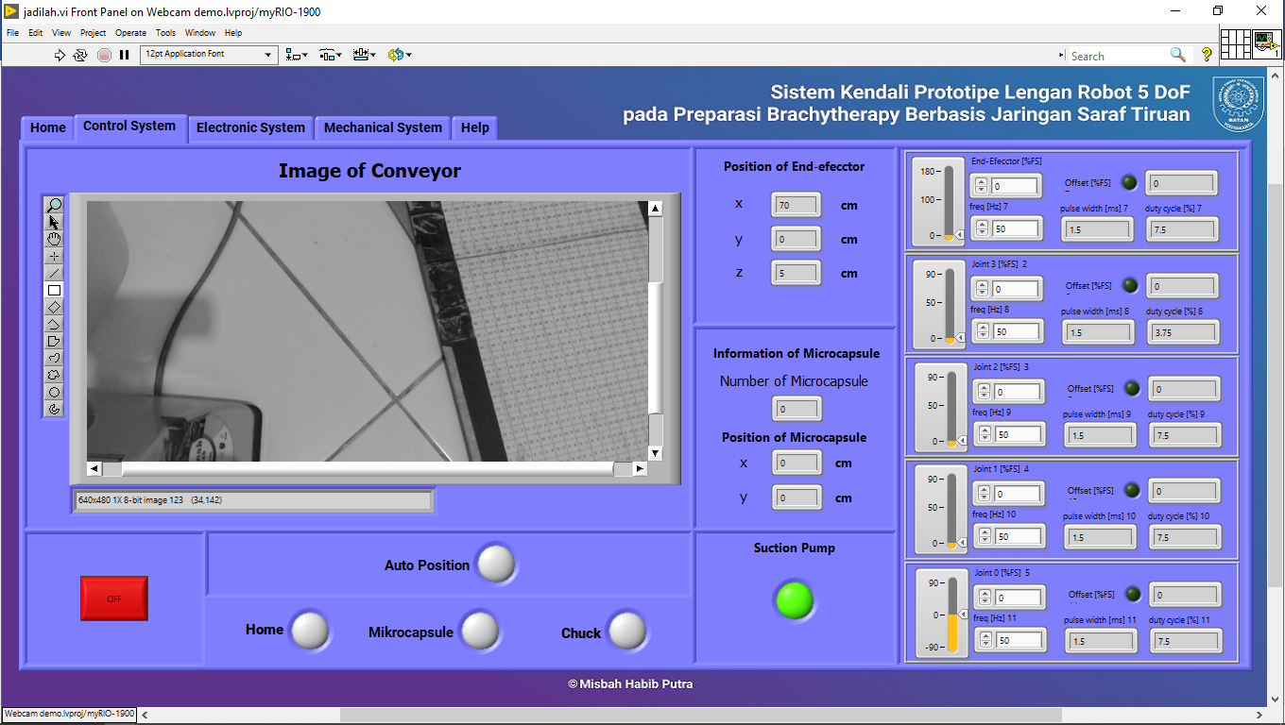
Figure 6. Software interface

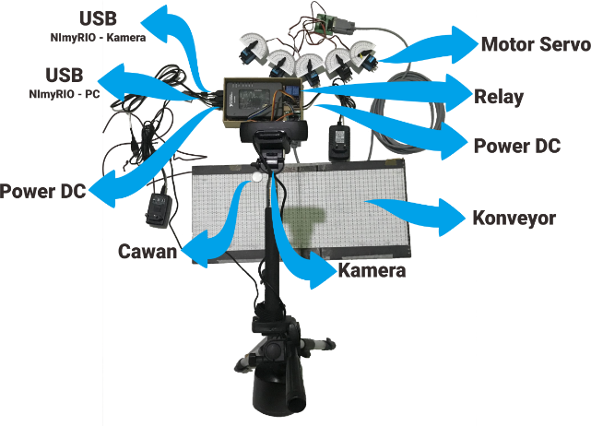
Figure 7. Control system hardware integration
Servo Motor Test
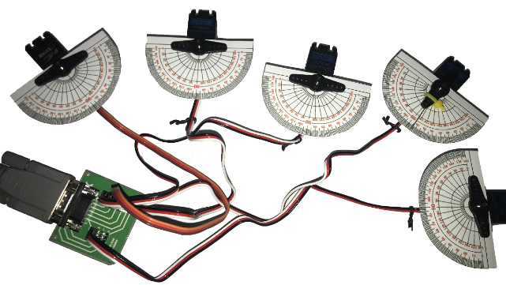
Figure 8. Servo motor test

The image processing test is performed by manually comparing the value of the observation position with the results obtained from image processing by Labview and the repeatability test of the image processing results. Figure 10 shows the setup of the image processing test.
The accuracy test of the image processing obtains an RMSE value of 0.03371 at $x$, 0.04361 at $y$, and 0.036767 at position distance. The factor influencing the error is the positioning of the observation results on the placement of the Cup using an accuracy of 1 cm. Furthermore, it is also affected by refraction or error in the dimensional angle of the object captured by the camera. With an average RMSE value of 0.038029 with an accuracy of 1 cm and a Cup size of 2.5 cm, the image processing has good accuracy.
Figure 9. Relay suction pump
Table 2. Relay suction pump test
No | Condition | Relay
 |  | Pump | Valve
1 | Suction Pump On | On | Off
2 | Suction Pump Off | Off | On

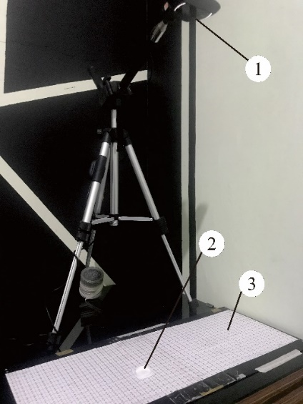 | Description:  - Camera  - Cup  - Conveyor with map organizer
Figure 10. Digital image capture setup

The repeatability test of the image processing obtains the RMSE value in the 2nd test of 0.028355 for $x$, 0.203784 for $y$, and 0.104973 for position distance. Meanwhile, the RMSE value in the 3rd test is 0.029665 for $x$, 0.030463 for $y$, and 0.025163 for position distance. In this case, an error occurs due to an observation error in the placement of the Cup with an accuracy of 1 cm. With an average RMSE value of 0.070401 at an accuracy of 1 cm, the repeatability of image processing is quite good.
5 DoF Robotic Arm Kinematic Test
The kinematic test of the 5 DoF robotic arm is carried out by performing an inverse kinematic test which is then compared to the forward kinematic movement. The inverse kinematic in this research results from an artificial neural network. The inverse kinematic neural network architecture of the 5 DoF robotic arm is shown in Figure 11.

Figure 11. Artificial neural network architecture
The shape of this artificial neural network is obtained from the training results on the data (attached) from the forward kinematic. The data is trained by epoch 2401 iterations with a time of 3 minutes 51 seconds. This inverse kinematic neural network has a training accuracy of 72% as shown in Figure 12.
Figure 12. Artificial neural network accuracy
The inverse kinematic test obtains an RMSE value of 2.78932 for $x$, 5.05205 for $y$, and 12.641 for $z$. The factor affecting the magnitude of the error value is the architectural form of the Artificial Neural Network. This Artificial Neural Network has an accuracy of 72% of the training data; therefore, it generates a high error value compared to the forward kinematic.
CONCLUSION
Based on the results, the following conclusions are obtained as follows:
- A 5 DoF robotic arm prototype control system was developed with inverse kinematic in Brachytherapy preparation.
- Using an artificial neural network, a 5 DoF robotic arm movement algorithm was developed from forward kinematic to inverse kinematic.
- The average RMSE value is 0 for the servo motor test; hence the control system and servo motor are working well.
- The control system can control the suction pump well.
- The average RMSE value is 0.038029 for image processing accuracy and 0.070401 for image processing repeatability. Therefore, the accuracy and repeatability of image processing on the control system are good.
- The RMSE value is 2.78932 for x, 5.05205 for y, and 12.641 for z in the inverse kinematic test of the artificial neural network. Therefore, the inverse kinematic accuracy of the artificial neural network needs to be redeveloped.
ACKNOWLEDGMENTS
In conducting research and preparing this final report, the authors have received much support and assistance from various parties. The authors express profound gratitude to:
1. Parents who always pray for and support completing the STTN-BATAN Diploma IV Electrical Mechanics study program.
2. Edy Giri Rachman Putra, Ph.D., as the Head of STNN-BATAN, and Adi Abimanyu, M.Eng as the Head of the Nuclear Technophysics Department, has permitted the authors to study.
3. Adi Abhimanyu, M.Eng as the main supervisor, and Dr. Muhtadan, M.Eng as the accompanying supervisor who has patiently and sincerely provided the best knowledge and guidance to the authors.
4. STTN-BATAN Lecturers who have provided knowledge to the authors.
5. Friends who have helped technically and non-technically as well as MAPALA WALANG.
6. All parties who have helped and supported.
REFERENCES
- E. P. Hadinoto, Rancang Bangun Sistem Kendali Prototype Lengan Robot 5 Dof Untuk Preparasi Mikro Kapsul Hdr Brachytherapy Berbasis Ni-Myrio 1900, Yogyakarta: Sekolah Tinggi Teknologi Nuklir, 2019.
- C. A. Wijaya and M. Muchtaridi, “Pengobatan Kanker Melalui Metode Gen Terapi,” Farmaka, vol. 15, no. 1, pp. 53-68, 2017.
- N. Fitriatuzzakiyyah, R. K. Sinuraya, and I. M. Puspitasari, “Cancer Therapy with Radiation: The Basic Concept of Radiotherapy and Its Development in Indonesia,” Indones J Clin Pharm, vol. 6, no. 4, pp. 311-320, Dec. 2017, doi: 10.15416/ijcp.2017.6.4.311.
- A. S. Baskoro and D. K. Yoga, “Pengaruh Pengaturan Parameter Las Laser Nd-YAG Terhadap Kualitas Pengelasan pada Mikro Kapsul Terapi Kanker Laju Dosis Rendah,” Proceeding Seminar Nasional Tahunan Teknik Mesin XI (SNTTM XI) & Thermofluid IV Universitas Gadjah Mada (UGM), 2012.
- R. Tjandrawinata, “Industri 4.0: Revolusi Industri Abad Ini dan Pengaruhnya Pada Bidang Kesehatan dan Bioteknologi,” Jurnal Medicinus, vol. 29, no. 1, pp. 31-39, 2016, doi: 10.5281/ZENODO.49404.
- M. Didi, E. D. Marindani, and A. Elbani, “Rancang Bangun Pengendalian Robot Lengan 4 DOF dengan GUI (Graphical User Interface) Berbasis Arduino Uno,” Jurnal Teknik Elektro Universitas Tanjungpura, vol. 1, no. 1, pp. 1-1011, 2015.

