PERSONAL DOSE DATABASE SOFTWARE
FOR EXTERNAL EXPOSURE

Chevy Cahyana

Radioactive Waste Management Development Center

ABSTRACT
PERSONAL DOSE DATABASE SOFTWARE FOR EXTERNAL EXPOSURE. The ERDBase software for external radiation dose database has been made using Borland Delphi 5.0 programming language. The software is proven to be efficient in utilizing memory. It has been tested for workers in the Safety and Environment Division of the Radioactive Waste Management Development Center. Using this software, one can save a large memory and increase service quality in personal dose management.

INTRODUCTION
In a nuclear facility, radiation exposure to radiation workers could be external or internal. External exposure may be due to direct irradiation from the source, immersion of airborne radionuclides, deposition of radionuclides onto the ground surface and onto person’s clothing and skin. Internal exposure follows from inhalation of radioactive material either directly from a plume or resuspension of contaminated surfaces, and from the ingestion of contaminated food and water or through contaminated wounds [1].
The safety and health of radiation workers at a nuclear facility must be protected. For this reason the dose received by a radiation worker should comply to Nuclear Regulatory Body (Bapeten) dose limit regulation. The annual dose limit for whole body and skin are 50 mSv and 500 mSv respectively.
The personnel dose monitoring system in Serpong nuclear facilities consist of internal and external dose monitoring. The internal dose monitoring is conducted through urine analysis (in vitro) and whole body counting (in vivo). The external radiation dose monitoring is done by applying Thermoluminescence Dosimeter (TLD) system. Radiation energy that is received by TLD card is converted into dose using the TLD Reader 6600 made by Solon Technologies Inc. Harshaw.
One of the Safety and Environment Division’s tasks is to monitor the external radiation dose received by radiation workers in Serpong. About 700 persons are monitored. Personnel radiation dose data must be stored for about 30 years, because the stochastic effect of radiation may occurs after a long period of time. The data must be available during this period of time. For this reason, it is necessary to have a computer software which can store a great amount of data in a relatively small size of memory. The ERDBase is dedicated to store personal external dose for all workers in Serpong for a period of more than 30 years.

METHODOLOGY

External Radiation Dose Monitoring
A person who works in radiation area must wear TLD badge on his pocket to monitor the external radiation dose. The external radiation dose that was recorded in a thermoluminescence dosimeter (TLD) card is read using the TLD Reader 6600 made by Solon Technologies Inc. Harshaw. In the TLD Reader, TLD card is heated by using heating system with flowing nitrogen gas. The radiation energy released from TLD card as photon radiation is multiplied by a photomultiplier that is included in the TLD Reader and converted to electrical charge in the order of nano coulombs. The convertion result is called the TLD card response. The TLD card response is used for calculating external radiation dose using the equation [4],

$D=\frac{\text{BxECC}}{\text{RCF}}−\frac{B_{0}{\text{xECC}}_{0}}{\text{RCF}}$ (1)

D = external radiation dose, mSv.
B = TLD card response, nC.
B0 = blank TLD card response, nC.
ECC = element correction coefficient
ECC0 = blank element correction coefficient
RCF = reader calibration factor

To obtain accurate monitoring results, TLD Reader should be calibrated at least once a year. The calibration of the TLD reader is done some TLD cards irradiated with a standard source.

The ERDBase Software Development
The ERDBase software was made using Borland Delphi 5.0 programming language. The flow chart of the software is shown in Figure 1. The software has two sub programs, i.e. annual data and personal data. The annual data subprogram stores the external radiation dose data annually; meanwhile personal data subprogram reads the annual data of each person.
The input data for annual data sub program are personnel identities and dose. All data are saved as database file. The annual data sub program has two kinds of data processing, i.e. data selection and data statistic.
The input data for personal data sub program are file names that have been processed by annual data sub program. In this sub program, the annual data are collected and selected based on ID or personnel’s name.

RESULT AND DISCUSSION

The ERDBase software preview is shown in Figure 2. This software has two menus, i.e. annual data menu and personal data menu. To open annual data menu click on “annual data” button. Click on “personal data” button to open personal data menu.

Figure 1. The ERDBase flow chart

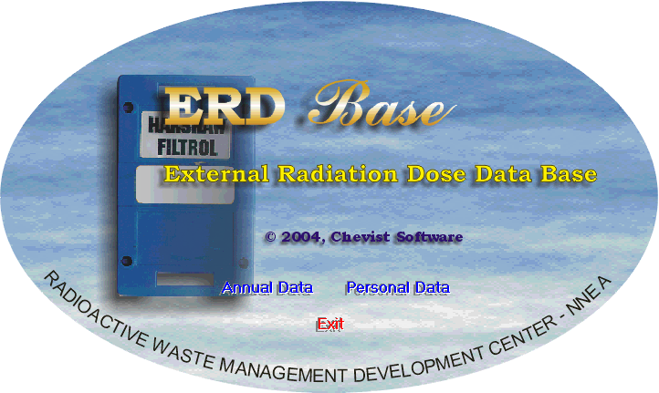

Figure 2. The ERDBase software preview

The annual data menu is sub program for annual data storing. The data stored in this menu are personnel identity and dose. External radiation dose data consist of skin dose and whole body dose. At Serpong site, external radiation dose monitoring is done periodically (every three months). From this work we can collect eight kinds of data. All data are then displayed as table sheet in the computer. The total dose for a year can be calculated automatically by clicking the “total dose” button. In order to make the report of dose monitoring result, the data in table sheet can be printed out directly.
As shown in Figure 3, the annual data menu is completed with two others additional facilities, i.e. searching facility and statistic facility. The purpose of searching facility is to search data based on selected category. There are four search categories, such as ID, name, center and division. Statistic facility is used for calculating maximum, minimum and average value of each data column.
For example, the external radiation dose data of year 2003 for “Keselamatan dan Lingkungan” division can be opened from data file named ‘DOSE2003.db’. Choose search category “Division” and fill in the box name of division, then click the “search” button. The “Keselamatan dan Lingkungan” division’s dose data for year 2003 are shown in the table. Click the “run” button in Statistic box to calculate the value of maximum, minimum and average of dose data. As shown in Figure 3, the skin dose maximum value for “Keselamatan dan Lingkungan” division is 3.08 mSv. This value is less than Dose Limits for skin dose recommended by the International Commission on Radiological Protection, i.e. 500 mSv per year.

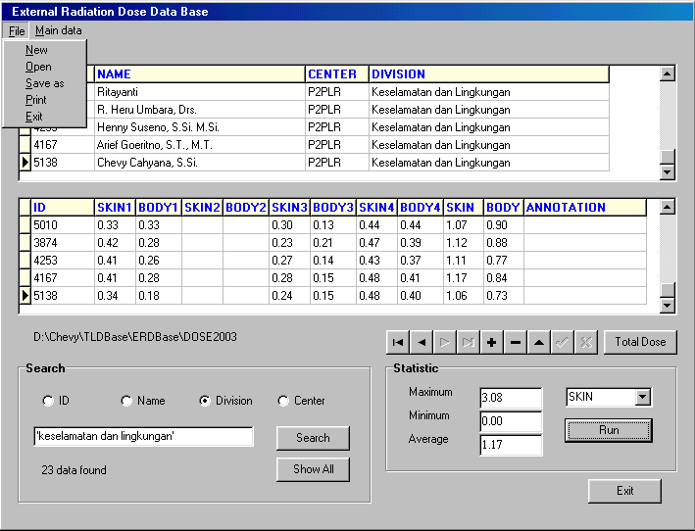
Figure 3. Annual data menu

The purpose of personal data menu is to search and collect radiation dose data from some data file annually. The process of searching data is done by select the data based on ID or name of person. The data will be shown as personal dose on this year, last year and accumulated dose. These data are useful for radiation worker when they want to go to abroad i. e. for training or tour of duty. The fluctuation of personal dose is displayed in personal dose chart. The x-axis of chart is year, and the y-axis is dose.
To open the personal dose data of a radiation worker, insert annual data files name into data source table using “insert file” button, fill in the search box the radiation worker’s ID or name, and then click “go” button. The radiation worker’s personal data and accumulated dose until this year are shown automatically. The data can be printed out as hard copy by click “print data” button.

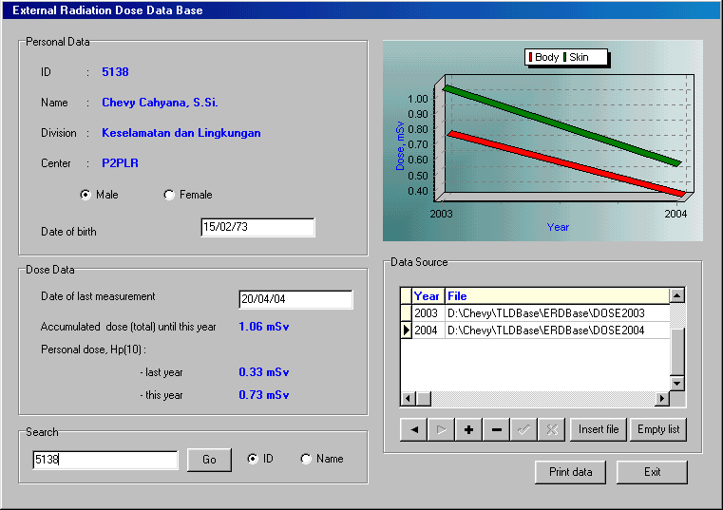

Figure 4. Personal data menu

CONCLUSION

The ERDBase software is useful for recording and processing the external radiation dose data at Serpong site. By using ERDBase software the storing, processing and reporting of data can be done in just one step. This can help the operators to increase the quality of services to the clients.

REFERENCES

[1] IAEA-TECDOC-1162, Generic Procedures for Assessment and Response During a Radiological Emergency, International Atomic Energy Agency, Vienna, 2000.
[2] Recommendations of The International Commission on Radiological Protection, ICRP No. 26, Pergammon Press, New York, 1982.
[3] Limits for Intakes of Radionuclides by Workers, ICRP No. 30, Pergammon Press, Oxford, 1978.
[4] STI / HARSHAW, TLD System 6600 Card Reader, User’s Manual, Solon Technologies, Inc./ Harshaw, Ohio, 1991.

---ooo0ooo---

