FORM OF ETHIC STATEMENTS

Article Title : EFFECT OF AGAR AND KAPPA-CARRAGEENAN ON THERMAL AND MECHANICAL PROPERTIES OF THERMO PLASTIC STARCH (TPS)

Authors (list all the names of the authors) : Akbar Hanif Dawam Abdullah, Putri Putih Puspa Asri, Rossy Choerun Nissa, Dina Fransiska, Nurhayati, Agusman, Hari Eko Irianto, Panji Priambudi, Sri Marliah

We hereby declare that:

- Papers submitted to this journal are original, written by the authors mentioned and have not been published elsewhere.

- This paper is not in the process of being published in another journal and will not be submitted for publication during the review process by this journal.

- The contents of this paper do not contain statements containing defamation or that are contrary to the law and do not contain things that disturb someone or violate the rights of property of another person or institution.

- We have obtained written permission from the copyright owner to quote the work created, contained in the article in our article.

Place / Date : Bandung / 19 Oktober 2020

Signature : 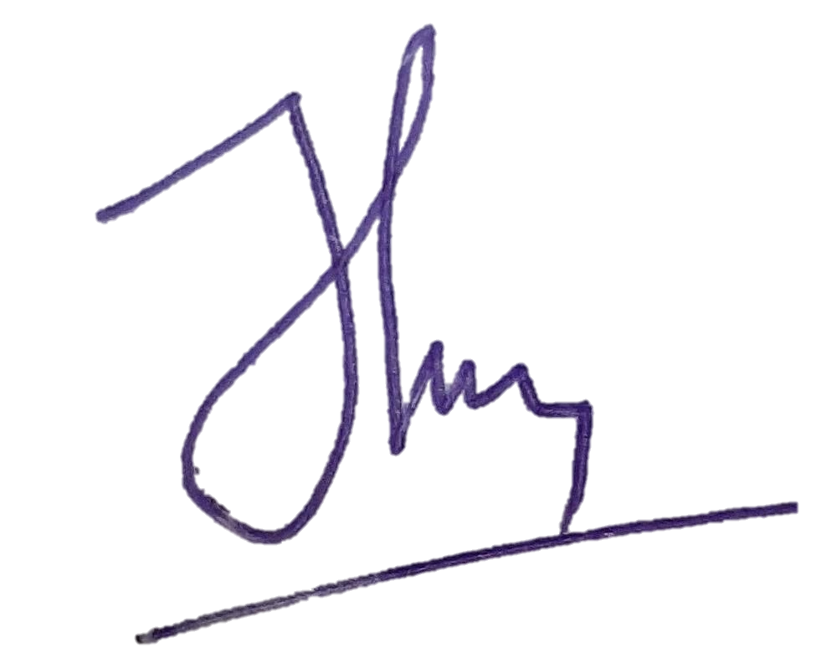

Clear name : Akbar Hanif Dawam Abdullah

