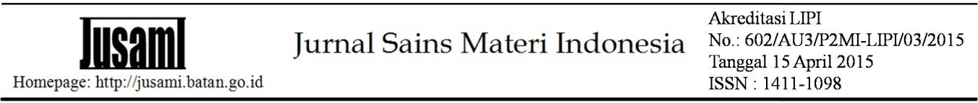
THE INFLUENCE OF COMPOSITION OF CNT (CARBON NANOTUBE) ON THE PHYSICAL PROPERTIES OF BIOPLASTIC MADE FROM CASSAVA STARCH
Masitoh¹, Akbar Hanif Dawam Abdullah², Rahmat Firman Septiyanto¹, Yus Rama Denny Muchtar¹, Isriyanti Affifah³
¹ Department of Physics Education - FKIP Sultan Ageng Tirtayasa University Jl. Raya Ciwaru No.25., Serang - Banten 42121
² Research Unit for Clean Technology, Indonesian Institute of Sciences Jl. Cisitu Sangkuriang Bandung – West Java 40135
³Department of Chemistry Education- FKIP Sultan Ageng Tirtayasa University Jl. Raya Ciwaru No.25., Serang - Banten 42121

E-mail: arim.masitoh14@gmail.com

Received: xxxxx Revised: xxxxx Accepted: xxxxx

ABSTRACT
THE INFLUENCE OF COMPOSITION OF CNT (CARBON NANOTUBE) ON THE PHYSICAL PROPERTIES OF BIOPLASTIC MADE FROM CASSAVA STARCH. Bioplastics are starch-based polymers that are easily degraded by microorganisms, so they can be used as an alternative to the use of conventional plastics. In this research, bioplastics made from cassava starch was made using glycerol as plasticizer and used MWCNTs (Multi-Wall CNTs) type CNT as reinforcement with variations in the composition of 0%, 1%, 2%, and 3%. Bioplastics are made with a dry method (dry blending) with stages of pre-mixing, mixing, hot press and cold press. Characteristics of bioplastic starch/CNT include tensile strength, biodegradation and morphological. The test results show that the addition of CNT composition affects the mechanical properties of bioplastics. The optimum value of tensile strength occurred in the addition of 2% CNT at 13.52 MPa. Biodegradable test results using the Aspergillus niger mushroom prove that bioplastic starch/CNT can be degraded well. The results of morphological characteristics in the form of SEM results showed that 3% bioplastic starch / CNT had cracks and resulted in decreased tensile strength. FTIR test results indicate the presence of a new functional group C≡C because of the addition of CNT.
Keywords: Bioplastic, cassava starch, glycerol, CNT, physical properties
ABSTRAK
PENGARUH KOMPOSISI CNT (CARBON NANOTUBE) TERHADAP SIFAT FISIKA BIOPLASTIK BERBAHAN PATI SINGKONG. Bioplastik merupakan plastik berpolimer berbahan dasar pati yang mudah terdegradasi oleh mikroorganisme, sehingga dapat dijadikan sebagai alternatif penggunaan plastik konvensional. Pada Penelitian ini dilakukan proses pembuatan bioplastik berbahan dasar pati singkong dengan penggunaan gliserol sebagai plasticizer dan digunakan CNT jenis MWCNTs (Multi Wall CNTs) sebagai penguat dengan variasi komposisi 0%, 1%, 2% dan 3%. Bioplastik dibuat dengan metode kering (dry blending) dengan tahapan pre-mixing, mixing, hot press dan cold press. Karakteristik bioplastik pati/CNT meliputi kuat tarik, biodegradasi dan morfologi . Hasil pengujian menunjukkan bahwa penambahan komposisi CNT mempengaruhi sifat mekanik bioplastik. Nilai optimum kuat tarik terjadi pada penambahan CNT 2% sebesar 13,52 MPa. Hasil uji biodegradable menggunakan jamur Aspergillus nigermembuktikan bioplastik pati/CNT dapat terdegradasi dengan baik. Hasil karakteristik morfologi berupa hasil SEM menunjukkan bahwa bioplastik pati/CNT 3% memiliki retakan dan mengakibatkan kuat tarik menurun. Hasil uji FTIR menunjukkan adanya gugus fungsi baru C≡C karena adanya penambahan CNT.
Kata kunci: Bioplastik, pati singkong, gliserol, CNT, sifat fisika

INTRODUCTION
One of the environmental problems in Indonesia is plastic waste. The amount of waste will continue to increase in proportion to the growth of population that continue to increase, the community is a comsumerist, the untimely management system and the living pattern of people who do not follow the "green lifestyle" will surely be followed by increasing waste production in Indonesia. In the year 2015, Jenne Jamback (Professor of Environmental Engineering, University of Georgia, USA) and his team released data that Indonesia threw plastic waste into the sea about 187.2 million tons [1].
Plastic based petrochemical polyethylene (PET), polyvinylchloride (PVC), polyethylene (PE), polypropylene (PP), polystyrene (PS) and polyamide (PA) have been widely used as a packaging material due to its large availability and affordability. In addition to such good mechanical work appearance such as tensile and tear strength, a good barrier to oxygen and carbon dioxide and heat stability of such petrochemical-based plastics, increase the use of packaging material [2]. Conventional plastics made from petroleum-based polymer synthesis cannot be degraded by the environment, as in landfills has caused serious problems for the environment. Conventional plastics made from petroleum have low degradation properties, at least plastic bags will be outlined 500-1.000 years, this causes plastics to become the source of most of the world's garbage and certainly damaging the environment [3].
One ingredient that is easily degraded by microorganisms is starch [4]. In addition to its easily degradable nature, starch comes from renewable natural resources, is universal and affordable, so that starch becomes a material that promises to be combined with boosters and fillers forming biocomposites polymer [5]. However, the plastics from the source of starch still have a certain deficiency in terms of physical properties, thermal stability, hygroscopicity compared to conventional plastics [6].
To make bioplastics, in addition to the needed starch, we also need a material that can be used as an adhesive (plasticizer). The use of plasticizer to increase the flexibility and extension of starch-based plastics. The plasticizer commonly used in the manufacture of bioplastics is glycerol. Use of glycerol as a plasticizer to lower chains of strong molecular interactions and enhance the process and mechanical strength capabilities.
The CNT (Carbon Nanotube) was discovered in the first time by Sumio Iijima in 1991. This material is an important concern in nanotechnology due to its very unique structure and nature [7]. The tensile strength of the CNT type MWCNT reaches 200 GPa, much higher than that of carbon fiber which is only 3-7 GPa, while the rigors can reach 1,2 Tpa, or five times greater than carbon fiber [8-9]. If viewed from the tensile strength of CNT type MWCNT can be used as a bioplastic amplifier because the bioplastic-based starch still has a weakness that is the nature of physics (strong drag) that is still less when compared to plastics conventional.
Based on previously conducted research stating that epoxy polymer with the addition of the CNT type of MWCNT can improve mechanical properties [10]. Therefore the author is interested to research the influence of the composition of CNT on bioplastic physics-based cassava and glycerol.

EXPERIMENTAL METHOD
Materials
Cassava starch materials used the production of PT. Budi Starch & Sweetener, Central Lampung, glycerol C₃H₅(OH)₃ Pure Analyse (PA) Merck KGaA Germany, as well as CNT type MWCNTs (Multi-Wall Carbon Nanotube) production Chengdu AlphaNano Tech, Co., Ltd.
The equipment used in this research is blender, labo plastomil, hot press, cold press, Universal Testing Machine to measure the mechanical properties of bioplastic composite samples with a speed of 50 mm/min. Bioplastic surface morphology is analyzed using SEM (Scanning Electron Microscope), FTIR (Fourier Transform InfraRed) method Attenuated Total Reflectance (ATR) to know the clusters found in bioplastic composites. While the tool used for biodegradable test is laminar air flow and autoclave.
Methods
The manufacture of bioplastics starch/CNT uses a dry blending method. Comparison between cassava starch and glycerol 3:1 with the addition of CNT 0%, 1%, 2% and 3% of the total mass of starch and glycerol.
The research procedure is done in this study as follows:
Pre-Mixing
The process of mixing cassava starch, glycerol and CNT until evenly, blender for ± 3 minute. Then weigh the ingredients as much as 50 grams.

Mixing
The process of mixing with the appliance of labo plastomil with a capacity of 50 grams, with a temperature of 130ºC within 10 minutes with a torque of about 3-4. The result is a chunk that is ready in press into a form of bioplastics. After the mixing process is completed, the chunks are weighed 3-6 grams.
Compression Molding
Bioplastic chunks in press with hot press is coated with an iron slab, using temperatures of 140ºC and P = 40 Kgf/cm2. The next stage is the cold press process for ± 4 minutes.

RESULT AND DISCCUSIONS
Physical Form
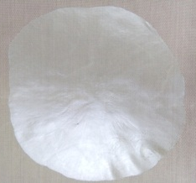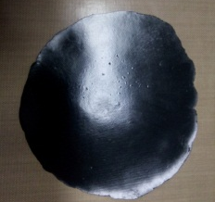
- (b)

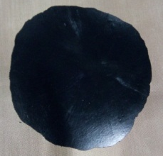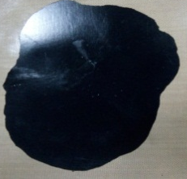
- (d)

Picture 1. Physical form bioplastic Strach/CNT (a) CNT %, (b) CNT 1%, (c) CNT 2%, and (d) CNT 3%
If viewed from the bioplastic result of starch/CNT produced, physically bioplastic cassava and glycerol starch has a clear/transparent colour shown picture 1(a), while bioplastic starch with additional CNT 1%, 2%, and 3% have a black colour shown in picture 1(b)-(d). The colour between the bioplastic starch/CNT 1%, 2%, and 3% do not have a significant difference, which tends to be the same colour. The texture of bioplastic starch/CNT picture 1(a)–(d) has a smooth texture and there are no cracks, but bioplastic starch/CNT 2% has a harder texture than bioplastics starch/CNT 0%, 1%, and 3%.

Tensile Strength
The mechanical properties are influenced by the sheer amount of content of bioplastic constituent components such as starch, glycerol, and CNT. This robust test of attraction can be noted how the material is in action against traction and knowing the extent to which the material is growing [11].

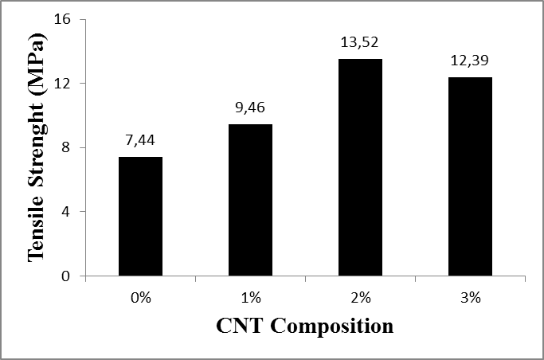
Picture 2. Tensile Strength bioplastic Starch/CNT
Based on a strong test result of the poll above, presented in picture 2 shows the influence of the addition of CNT on bioplastics increases the strong value of tensile. The highest tensile strength occurs in the bioplastic starch/CNT 2% of 13.52 MPa which then decreased to 12.39 MPa on the bioplastic starch/CNT 3%. A strong increase in attraction is caused by increased interaction of interesting tensile styles on molecules. The addition of the amount of CNT of MWCNT more than 2% apparently does not increase strength and rigors, even tends to decline [12]. The still weak interface ties between the CNT and the bioplastic matrix cause the strengthening of bioplastics not to be maximized, this is also due to the lack of dispersed CNT in bioplastic matrices. Therefore, bioplastics that are added by CNT 3% have decreased. SEM results indicate an excessive addition of CNT on bioplastics resulting in bioplastics have cracks and not bonded perfectly with starch and glycerol.
Biodegradable Test
Testing biodegradable on this research to know the nature of bioplastic biodegradation by using methods of planting fungi Aspergillus nigertype on bioplastic surface.
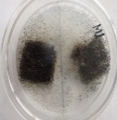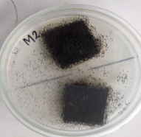
- (b)

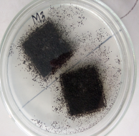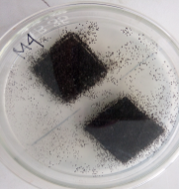
(c) (d)

Picture 3. Biodegradable test bioplastic starch/CNT (a) CNT 0%, (b) CNT 1%, (c) CNT 2%, and (d) CNT 3%
Based on biodegradable test results, presented in picture 3 shows that with the addition of CNT to bioplastics can increase the growth of microorganisms faster. Microorganisms have already covered >60% of the bioplastic surface of starch/CNT within 7 days and this result indicates biodegradable bioplastics at a heavy growth level according to ASTM G21-70.
Bioplastic Starch/CNT Morphology
SEM (Scanning Electron Microscopy)
SEM (Scanning Electron Microscopy) is a tool that can be used to study or observe the details of the shape and microstructure of the surface of an object that can not be seen by the eye or by optical microscope.
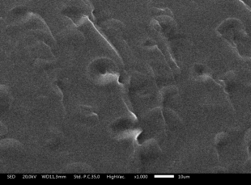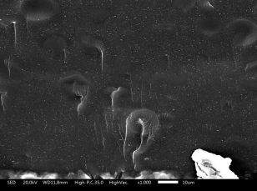
pore
pore

10 μm

10 μm
- (b)
pore
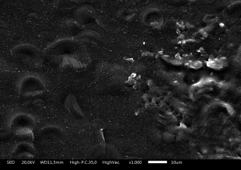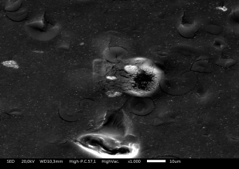
crack
pore

10 μm

10 μm
(c) (d)

Picture 4. SEM bioplastic starch/CNT (a)CNT 0%, (b)CNT 1%, (c)CNT 2%, and (d)CNT 3%
Based on the results of SEM above, which presented the picture 4, bioplastic starch/CNT there is a pore on all the samples shown picture 4(a)–(d), this pore occurs because of the moisture that comes into the bioplastic. Bioplastic Starch/CNT 3% shown in picture 4(d) There are cracks that are more noticeable than the picture 4(a)-(c), this is what causes a strong tensile from bioplastic starch/CNT 3% decreased. The addition of excessive CNT causes the bioplastics to be produced more rigid and this can lead to greater cracks. The results of this SEM test explained the related strong test result of the tensile on the bioplastic starch/CNT 3% decreased.

FTIR (Fourier Transform Infrared)
This FTIR test aims to determine the interaction between cassava starch as a matrix and glycerol as a plasticizer used in the manufacture of bioplastics and CNT as an amplifier.
Picture 5. Results analysis of bioplastic FTIR starch/CNT
Based on the analysis of the resulting bioplastic FTIR of starch/CNT 0% showed the emergence of the O-H cluster at 3297,66 cm⁻¹, C-H in the wavelength of 2931,02 cm⁻¹, C=O at 1644,54 cm⁻¹, and C-O in the wavenumber 1017 cm⁻¹. With the function cluster of C=O carbonyl and ester (COOH) on plastics synthesized identifying the plastic has the ability of biodegradability. In the bioplastic starch/CNT 1%, 2%, and 3% there is a new function group that emerged that is C≡C on the number of waves 2118,18 – 2113,41 cm⁻¹. It is stated that the addition of the CNT in bioplastics raises a new function group which signifies an interesting tensile force on the bioplastic matrix.

CONCLUSION
Cassava-based bioplastics that use glycerol as a plasticizer and the addition of CNT optimum in the addition of CNT 2%. Tensile strength bioplastic starch/CNT highs of 13.52 MPa. Bioplastic Starch/CNT can be well depreciable for 7 days using Aspergillus niger, and the emergence of C≡C function groups due to the addition of CNT.

ACKNOWLEDGMENT
The author's acknowledgments convey to LPTB-LIPI Bandung who has financed and allowed writers to do research. Department of Physics Education-FKIP UNTIRTA that fully supports authors for this research. All parties who have provided assistance and advice in the implementation of this research.

REFERENCES
- J.R. Jambeck, R. Geyer, C. Wilcox, T.R. Siegler, M. Perryman, A. Andrady, R. Narayan, H.K. Lavender. “ Plastic Waste Inputs from Land into the Ocean.” Science 347, 768, 2015.
- A.H.D Abdullah, S. Pujiraharti, M. Karina, O.D. Putri, R.H Fauziyyah. “Fabrication and Characterization of Sweet Potato Starch-based Bioplastics Plasticized with Glycerol.” Journal Biological Science, 57-64, 2019
- Melani Ani Netty Herawati, A. Fajri Kurniawan. “ Bioplastik Pati Umbi Talas melalui Proses Melt Intercalation.” Distilasi, Vol.2 No.2 September, Hal 53-67, 2017
- Rifaldi Anugrah, Irdoni Hs, Bahruddin. “ Sifat dan Morfologi Bioplastik Berbasis Pati Sagu dengan Penambahan Filler Clay dan Plasticizer Gliserol.” Jom FTEKNIK Volume 4 No.1 Februari, 2017
- Santana R.F, R.C.F Bonomo, O.R.R Gandolf, L.B. Rodrigues, and L.S. Santos et.al. “ Characterization of Starch-based Bioplastic from Jackfruit Seed Plasticizer with Glycerol.” J. Food Sci. Technol., 55: 278-286, 2018
- Isroi, A. Cifriadi, T. Panji, N. A. Wibowo, and K. Syamsu. “Bioplastic Production from Cellulose of Oil Palm Empty Fruit Bunch.” IOP Conf. Ser. Earth Environ. Sci., vol. 65, no. 1, 2017.
- Iijima S .” Helical Microtubulec of Grafhitic Carbon. Nature.” 1991
- William D. Callister JR.”Material Science and Engineering An Introduction, Fourth Edition .”. John Wiley & Sons Inc, 1997.
- Barai P, Weng G J. “A Theory of Plasticity for Carbon Nanotube Reinforced Composite.” International Journal of Plasticity 27 : 539-559, 2011
- Hermawan Judawisastra, Christian Harito, Akbar H. Dawam Abdullah.” Effect of Amide Functionalization and Precuring on Tensile Properties of MWCNT/Epoxy Nanocomposite.” Journal of Macromolecular Symposia, Volume 35/ issue 1, p 88-95, 2015
- Darni, dkk.” Produksi Bioplastik dari Sorgum dan Selulosa Secara Termoplastik.” Jurnal Rekayasa Kimia Dan Lingkungan, 10 (2), 2014
- Prolongo S G, Gude M R, Urena A. “Improving the Flexural and Thermomechanical Properties of Amino-Functionalized Carbon Nanotube/Epoxy Composite by Using a Pre-Curing Treatment.” Composite Science and Technology 71 : 765-771, 2011

