STATISTICAL ANALYSIS OF X-RAY GENERATOR LEAKAGE TEST AT HOSPITALS AND HEALTH CENTERS   
IN CENTRAL JAVA PROVINCE

Risky Nurseila Karthika1*, Toto Trikasjono2, Supriyono3

1,2,3) Sekolah Tinggi Teknologi Nuklir,Yogyakarta, Indonesia

*Corresponding email: riskynurseila@gmail.com

ABSTRAK

**ANALISIS STATISTIK HASIL UJI KEBOCORAN PESAWAT SINAR-X PADA INSTALASI RADIOLOGI PROVINSI JAWA TENGAH.** Tingkat kelayakan pesawat sinar-X perlu diuji dengan melakukan pengujian kebocoran radiasi. Hasil pengujian kebocoran pesawat sinar-X UPPM STTN-BATAN yang telah dilakukan belum dilengkapi dengan analisis tingkat kebocoran pesawat sinar-X di setiap tahunnya. Penelitian ini dilakukan untuk menganalisis hasil data statistik tingkat kebocoran pesawat sinar-X di instalasi radiologi pada beberapa kabupaten di provinsi Jawa Tengah, yang diinisialkan dengan kabupaten A, B, C, D, E, F, G, H, dan I dari tahun 2012-2014. Metode analisis yang digunakan adalah metode statistik nonparametrik uji kecocokan karena dapat menganalisis data kebocoran pesawat sinar-X di beberapa tempat sekaligus. Nilai rata-rata kebocoran radiasi tertinggi pesawat sinar-X berada di bawah ambang batas kebocoran 1 mGy/jam. Namun, terdapat beberapa pesawat sinar-X di kabupaten H, I, dan C yang melebihi ambang batas, dengan persentase kebocoran berturut-turut yaitu 7,6%; 37,5%; dan 14,2%. Kondisi kebocoran pesawat sinar-X di beberapa kabupaten Provinsi Jawa Tengah dapat lebih mudah diketahui karena data hasil pengujian telah dibuat dalam bentuk peta tematik dan *window chart* menggunakan metode sistem informasi geografis dengan *ArcView* 3.3. Hasil statistik nonparametrik uji kecocokan data yang diperoleh menunjukkan bahwa prosedur pengoperasian pesawat sinar-X pada masing-masing instalasi radiologi pada beberapa kabupaten provinsi Jawa Tengah memiliki nilai proporsi data laju kebocoran di bawah 1 mGy/jam, dengan nilai statistik per kabupaten A, B, C, D, E, F, G, H, I berturut-turut yaitu 2,31033<9,2364; 0,2944442<13,3616; 4,6559925<10,6446; 0,1884249<12,0170; 0,0576894<4,6052; 0,4609793<2,70554; 0,9539133<7,7794; 17,452924<34,3816; 7,2867225<12,0170.

Kata kunci: Pesawat sinar-X, sistem informasi geografis, statistik nonparametrik, uji kecocokan

ABSTRACT

**STATISTICAL ANALYSIS OF X-RAY GENERATOR LEAKAGE TEST AT HOSPITALS AND HEALTH CENTERS IN CENTRAL JAVA PROVINCE**. Several research has been conducted yearly on X-Ray generator leakage by the Research Community and Devotion Polytechnics Institute of Nuclear Technology. However, none have determined the feasibility of X-rays in analyzing radiation leakages. Therefore, this research aims to conduct a statistical analysis test to determine the X-ray generator’s leakage level in radiology installations at several districts in Central Java province, initialized with A, B, C, D, E, F, G, H, and I from 2012-2014. This research was carried out using a non-parametric statistic method due to its ability to analyze data in several places simultaneously at an average radiation leakage value of under 1 mGy/hour. However, some X-Ray Generators at districts H, I, and C exceed the limit of radiation leakage with row percentages of 7.6%, 37.5%, and 14.2%. The condition and information of the ranges in X-Ray Generator leakage at several districts in Central Java can be easily identified because the data is inputted into the thematic map and window chart using the Geographical Information System and computed by ArcView 3.3. The non-parametric statistics results showed that the operating procedure at each radiological installation in some districts of Central Java Province had been conducted in good quality. The data proportion in districts A, B, C, D, E, F, G, H, and I are equal to the statistics values of 2,31033<9,2364; 0,2944442<13,3616; 4,6559925<10,6446; 0,1884249<12,0170; 0,0576894<4,6052; 0,4609793<2,70554; 0,9539133<7,7794; 17,452924<34,3816; 7,2867225<12,0170, respectively.

Keywords: X-ray generator, non-parametric statistic, goodness of fit test, geographical information system

INTRODUCTION

Background

An X-ray generator is a radio-diagnostic device widely used in radiology installations due to its ability to diagnose diseases in the body through radiation. Asides from its capabilities, this device can also produce radiation hazards for radiology operators, patients, and the community. Therefore, based on the Regulation of the BAPETEN Head No. 15 of 2014 concerning the maintenance and operation of X-ray generators, it is imperative to check the feasibility level of the equipment through compliance and tube leak tests. The X-ray tube leakage test is a measurement technique used to determine the dose rate of the device at 1 meter from the focal spot in operating conditions of maximum kV and mA or mAs, with the collimator window closed [1]. The College of Nuclear Technology with the Research and Community Service Unit (UPPM), in implementing the *Tridharma* of Higher Education, has measured the leakage level of X-ray generators in Central Java Province. However, the test results are limited due to each generator's exposure rate reports from several X-ray devices. This report will be submitted to each radiology installation for evaluating leakage exceeding the specified limit.

Data on X-ray generator leakage measurements were collected from each district in Central Java Province. The collected data were analyzed and used to predict future events based on existing and past data using the Geographical Information System (GIS).

There are some advantages associated with using the GIS method in making thematic maps needed for the distribution of X-ray generator usage in several districts of Central Java. For instance, it is used to determine the attribute data, combined with spatial data in the form of a base map of Central Java Province to become an interesting and informative thematic map. Moreover, with the GIS method, a window chart capable of analyzing the leakage value based on the brand of the X-ray generator can be made. The results obtained are easy to understand and useful for UPPM to classify districts based on the leakage level geographically. These results can also be used by relevant agencies such as the Central Java Provincial Health Office to evaluate leakage that exceeds the safety limit in some districts.

By November 2014, it was gathered that a total of 75 generators in 9 districts had been tested for X-ray leaks. Each generator was measured to determine its up, down, front, back, left, and right positions. However, certain statistical methods are needed to test whether the observed frequencies are consistent with the theoretical frequencies.

The first is using a suitable non-parametric statistical method with a match test to determine the consistency of their results. Supposing it is consistent, then there is no significant difference between the observed and the theoretical frequency. In other words, the leakage value of the X-ray generator in each year is considered below or above the allowable limit. Furthermore, when the leakage distribution shows values below 1 mGy/hour, the X-ray generator operating and maintenance procedures for all generators in one district have been carried out correctly.

BASIC THEORY

X-ray

According to the Regulation of BAPETEN Head Number 15 of 2014 concerning Radiation Safety in the Use of Diagnostic and Interventional Radiology, X-ray is a device used to ionize radiation safety in the medical field. It is an action taken to protect patients, workers, community members, and the environment from the dangers of radiation. Subsequently, the limit of the radiation leakage value referred to in paragraph (1) is 1 mGy (one milligray) within 1 hour and a m (meter) from the focus position with the maximum continuous current at kVp (maximum kilovolt peak).

X-ray is the process of striking high-energy electrons on a material, which bounces out on impact. Therefore, the transfer of electrons from the outer shell to the inside is accompanied by the release of X-ray [2]. Subsequently, X-ray tubes and generators are indispensable components used to control and produce x-rays. This tube and other supporting components are used to produce X-ray, while the generator functions as a source of electrical voltage and a tool to control the manufactured energy. The basic components of an X-ray system are shown in Figure 1.

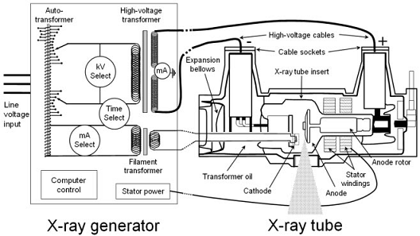

1. The basic components of the X-ray system [3]

Radiation Safety Standard

X-ray generators are widely used in the medical field for diagnostic and therapeutic purposes. However, this device is the potential to radiation hazard, therefore adequate attention needs to be paid to protection techniques. There are three basic principles associated with radiation protection, namely time, distance, and shielding.

Therefore, it is imperative to conduct a conformity test on the X-ray generator used for medical exposure to fulfill the appropriate standard. The purpose of the fit test is to ensure radiation safety during usage. One of the suitable ways to identify and ensure the radiation leaking from the generator tube is still within the safety standard limits is by conducting the tube leakage test [4].

According to article 47 paragraph, 2 of the Regulation of the BAPETEN Head No. 15 concerning Radiation Safety in the Use of Diagnostic and Interventional Radiology X-Rays, the limit of radiation leakage value is 1 mGy per 1 hour at 1 m from the focal spot with strong continuous current conditions at maximum kVp [1].

X-Ray Generator Leakage Testing

The X-ray tube leakage test is used to measure the radiation dose rate at a 1-meter from the focal spot at a maximum operating rate of kV and mA or mAs when the collimator window is closed [1].

This test is carried out by installing a dosimeter at a distance of 1-meter in a circle with an spherical dimension from the focal spot. Measurements are made at 6 points (90° angle), namely the top (a), bottom (b), front (c), back (d), left (e), and right (f) to the X-ray generator. Furthermore, 2 digital dosimeters are used, which are placed at 3 pairs of points in a row, namely up-down, left-right, and front-back at an angle of 90° to obtain 6 measurement points.

Figure 2 describes the position and measurement points for a 6-point (90°) X-ray leakage test.

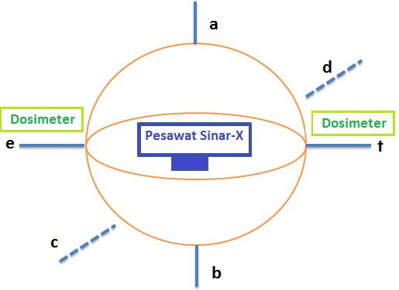

1. Measurement of 6-point X-ray generator leakage test

Geographical Information System (GIS)

Geographical Information System (GIS) is one of the most commonly used models for decision making, planning, and analysis. GIS provides a spatial analysis of the attribute data. It also has the capabilities of providing two types of information models, in the form of spatial and descriptive with their relationship explained topologically. GIS as a series of systems utilizes digital technology to perform spatial analysis. It also uses hardware and software from a computer to perform data processing [5].

The rapid growth of science and technology management has led to the necessary use of GIS. This device consists of various facilities for managing spatial and descriptive data in a coherent and organized database for efficient information storage. The ArcView software developed by ESRI has the speed and capability of planning and processing in various fields [6].

The GIS method has 4 main implementation stages. The first is the data input stage, which consists of two types, namely graphic (spatial) and attributes data (tabular). The data are interrelated and stored in a data set or database. Data input is carried out in various ways, such as scanning or converting continuous graphic data into discrete data consisting of image pixels. Another method of inputting data is by converting analog graphics into digital. The final method is tabulation, which is the process of arranging graphic and attribute data in tabular form. The second is the data management stage, which is associated with the process of analyzing data attributes, and graphics to obtain information. The third stage is data manipulation and analysis. In this method, the data presentation, grouping, separation, estimation of parameters, as well as constraints and modeling functions, are conducted. The last stage in the GIS method is the output, which functions to display quantitative and qualitative information as well as the results of geographic data analysis. This can be in the form of thematic maps, digital maps, or tabular data [7].

ArcView

ArcView is a spatial data processing software used in GIS analysis. It was designed and developed by the Environmental Systems Research Institute (ESRI) and used for applications in the field of mapping. This software is currently available in the market and capable of performing data exchange and mathematical operations. Furthermore, it has the ability to display spatial and attribute information simultaneously, create thematic maps, provide programming languages (scripts) as well as perform other special functions with the help of extensions[8].

Maps and Graphics

Thematic maps provide special information using certain symbols, such as color gradations, lines, scattering patterns, and graphics. It is often used to describe a phenomenon consisting of groups and levels in a particular area, which is then described in the form of classification. Furthermore, thematic maps are used to determine certain themes and interests, such as population, and transportation using a simplified map of the earth as a basis for laying out thematic information. It also describes geographic concepts, such as population, density, climate, movement of goods, etc [9]. According to [10], thematic maps display various types or classes of information based on certain themes, such as geological location, population, economic activity, forest, hydrology, etc [10].

Meanwhile, graphics are used to complement the map displayed, thereby making it easy to be read. Graphic appearances can be created in a template read as a complete image with certain shapes such as bars, circles, lines, etc. A combination of graphs and thematic maps is usually used to display information that compares the level of a phenomenon from one area to another [9].

Map Component

A good map is equipped with the right components, which makes it easy to read, interpret, and understand. The components that need to be met in a map include a title, scale, legend, directions, symbol, source, and year of creation [9].

Statistical Data Processing

Parametric statistics is a statistical technique whose population or distribution is based on a normal model with homogeneous variances. Meanwhile, non-parametric statistics is a technique whose population parameters or distribution assumptions do not follow a certain model or are independent with homogenous variances [11]. There are several advantages associated with the extensive analysis of non-parametric statistics. For instance, it can solve the problem of sample size divergence, such as when the statistical result of the sample deviates, and the null hypothesis is true. This method can also be used to analyze data whose distribution model is not certain [12].

Subsequently, non-parametric characteristics are nominal/ordinal data scales in which the distributed population is unknown or abnormal. Another advantage of the non-parametric statistical method is its flexibility in using any data type irrespective of the amount. This method can also be used on data from normally or abnormally distributed [13]. Several tests on non-parametric statistics were then conducted, including Chi-Square Test, Median Test, Sign Test, Wilcoxon Signed Rank Test, Mann-Whitney Test, Kruskal-Wallis Test, Spearman Level Correlation, and W Kendall Concordance Test [14].

The Chi-Square test is used to carry out several tests, such as the Goodness of Fit Test, the independence test, and the homogeneity test. This research was conducted using the compatibility test to determine the suitability, the problem faced, and frequency. The null hypothesis is accepted, assuming there is no difference between the observed and theoretical frequency. Conversely, it is rejected, assuming there is no consistency. This means the observation results do not support the theoretical hypothesis. Furthermore, the formula used is as in Eq (1).

$χ^{2}count=\sum_{i=1}^{n}{\frac{{(O_{i}-E_{i})}^{2}}{E_{i}}}$ (1)

With:

$O_{i}$ = observed frequency

$E_{i}$ = *np =* theoretical frequency

$n$ = number of samples

$p$ = probability

The hypothesis testing procedure is carried out with the following steps:

1. Express $H_{0}$ and the alternative hypothesis
2. Determine α or level of significance (level of significance)
3. Determine $χ^{2}count$
4. Determine chi-square test statistics and degrees of freedom
5. Compare the results of $χ^{2}count$ and $χ^{2}table$ chi-squared. The $χ^{2}table$ chi-squared is shown in Figure 3
6. Determine whether to accept or reject the chi-square value and the $H_{0}$ decision [14]

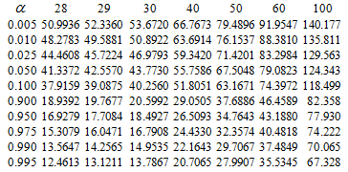

1. $χ^{2}table$ chi-squared

Method

Research on Diagnostic X-Ray Generator Leakage Analysis in Central Java Province Using the Geographical Information System (GIS) was carried out from November 2014 - April 2015. The stages in this research are as follows 1) X-ray generator leakage testing in 2014, 2) Conversion of measurement results into units of leakage rate, 3) Collecting data from the UPPM-STTN community service at several Health Installations in Central Java Regency from 2012-2014, 4) Making Thematic Maps and Window Charts of X-ray generator leakage levels at several Health Installations in Central Java Regency from 2012-2014 using ArcView 3.3 software, 5) Calculating group frequency distribution analysis, and 6) Non-parametric statistical testing using the chi-square and the Goodness of Fit test method.

Figure 4 shows the overall research flow chart:

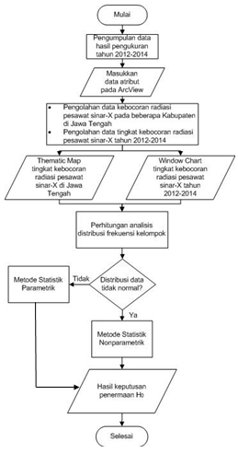

1. Research flow chart

2014 X-Ray Generator Leak Measurement

Before starting the measurements, the radiology installation in District A was inspected in December 2014. The number of generators measured is 6 units, and the specifications of the X-ray generator to be tested for leakage levels are determined. Furthermore, X-ray leakage measurements are carried out in the working order, as shown in Figure 5.

1. 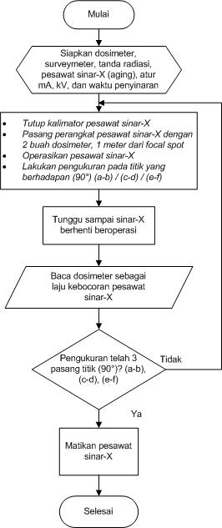
2. X-ray leakage measurement flow chart

Conversion of Measurement Results into Leakage Rate Units

Based on the provisions of BAPETEN Regulation No. 15 of 2014, the maximum allowable X-ray leakage time is 1 mGy/hour. Primary data taken from the measurement results using a dosimeter is in the form of the effective dose value (nSv). Therefore, the value needs first to be converted to mGy/hour.

UPPM-STTN X-ray leakage data collection 2012-2014

The Research and Community Service Unit - College of Nuclear Technology, in carrying out the *Tridharma* of Higher Education, measured the level of X-ray generators leakage in Central Java Province. However, the test results are still in the form of exposure level reports from several X-ray generators. In this research, X-ray generator leakage data were grouped in Districts A, B, C, D, E, F, G, H, and I from 2012 to 2014.

Thematic Map and Window Chart Making

Thematic Maps and Window Charts are used to easily determine and analyze data patterns and trends in a map. Figure 6 shows a flow chart for making the Thematic Map and Window Chart using the GIS method with ArcView 3.3. software.

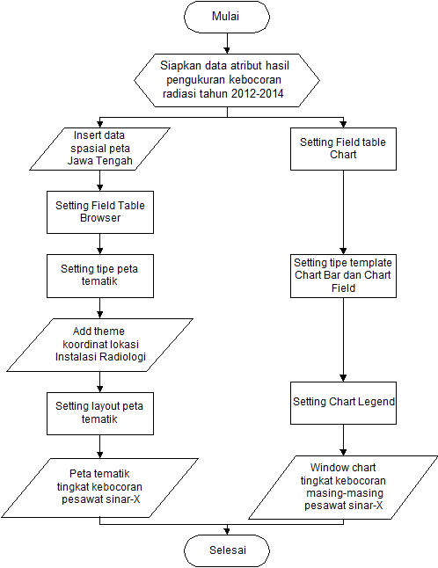

1. Flowchart of making Thematic Map and Window Chart

Statistical Analysis

Several stages are carried out in the statistical analysis section, including calculation of group frequency distribution and non-parametric test.

Results and Discussion

This section analyzes the results and discussion of this research. The results consist of thematic maps of X-ray generator leakage at Radiology Installations in several districts in Central Java Province. Moreover, a window chart of the radiation leakage level of X-ray generators was obtained from 2012 to 2014, which are grouped based on the brand and level of leakage. The calculation of group frequency distribution analysis and the Goodness of Fit Test is also carried out to determine the consistency of the data. This indicates whether there are differences in conditions, operating procedures, or X-ray generator maintenance installed at each district from 2012-2014.

Thematic Map of X-ray leakage at the Radiology Installation in Central Java Province

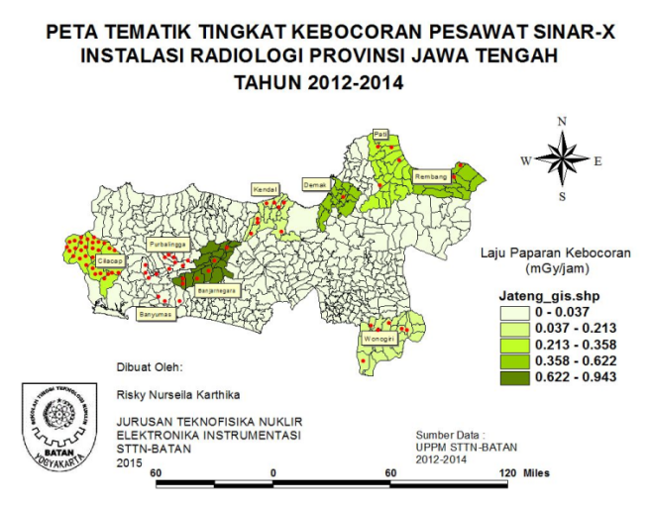

1. Thematic map of X-ray generator leakage level at radiology installations in Central Java province

Figure 7 shows the condition of the X-ray generator leakage at the Central Java Provincial Hospital and Health Center. The leakage levels are categorized into 5 classes. The first, second, third, fourth and fifth classes have values of 0-0.037, 0.037-0.213, 0.213-0.358, 0.358-0.622, and 0.622-0.943 mGy/hour. The districts in the first class or the lowest radiation leakage level are D and B. Districts C, and A are included in the second class with higher radiation levels than the first. The third class is Districts G and H, while the fourth consists of E and F. The last class with the highest radiation leakage rate range is 0.622-0.943 and in District I. This indicates that the leakage level in all districts in Central Java Province is below the standard value. This is in accordance with the Regulation of BAPETEN Head Number 15 of 2014 concerning Radiation Safety in the Use of Diagnostic and Interventional Radiology X-Rays, which is less than 1 mGy/hour.

Window Chart of X-ray generator leakage levels for 2012-2014

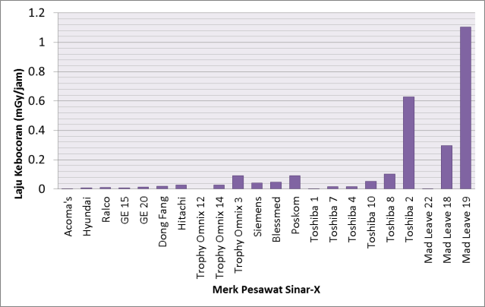

1. Window Chart of district A, B, and C X-ray leakage levels for 2014

Figure 8 shows a window chart of the radiation leakage level of the X-ray generator in 2014. The Window Chart of Districts A, B, and C in 2014, can be easily grouped based on the brand of X-ray generator, from the lowest to the highest value. Acoma's brand has the lowest average maximum leakage, 0.001206 mGy/hour. Meanwhile, Hyundai, Ralco, GE, Dong Fang, Hitachi, Trophy Omnix, Siemens, Blessmed, Poskom, and Toshiba are also below the permissible leakage threshold, which is below 1 mGy/hour. Of the 3 Mad Leave X-ray generators measured, 1 exceeded the exposure level of 1 mGy/hour. Meanwhile, the largest leakage level is the Mad Leave brand with the F30-III tube type.

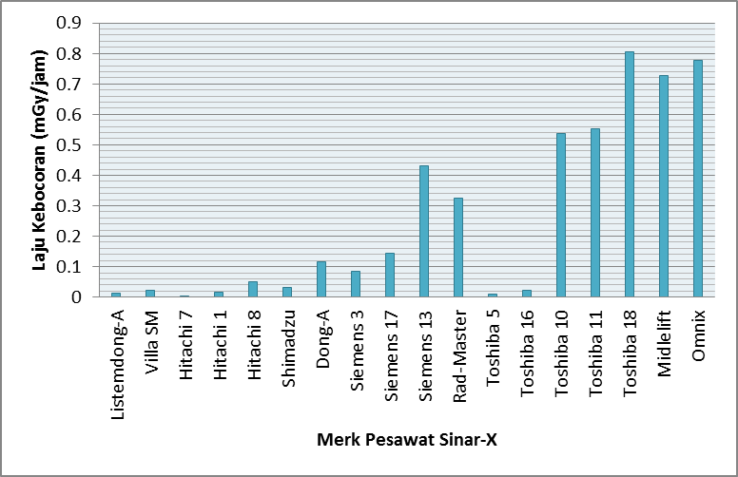

1. Window Chart of District D, E, F, and G X-ray leakage levels for 2013

Figure 10 shows the Window Chart of the X-ray Leakage Levels for Districts D, E, F, and G in 2013. The X-ray generator with the lowest leakage level of 0.01276 mGy/hour is Listemdong-A. Similarly, Villa SM, Hitachi, Shimadzu, Dong-A, Siemens, Rad Master, Toshiba, Midlelift, Omnix installed in Districts D, E, F, and G in 2013 are below the leakage threshold of 1 mGy/hour. This shows that the highest value found in the Toshiba brand with the BLF-15 tube type has a leakage exposure level of 0.8042 mGy/hour.

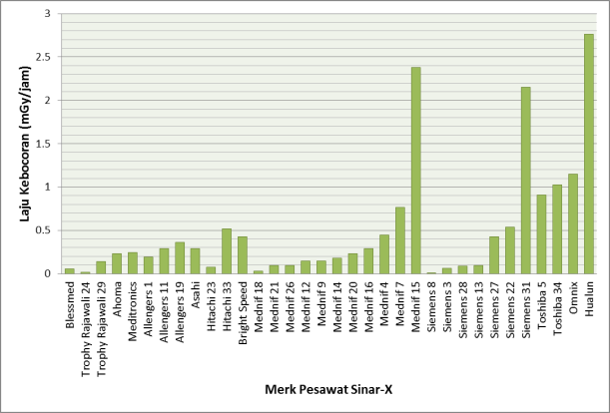

1. Window Chart 2012 district H and I X-ray generator leak levels

Figure 10 shows that a total of 34 X-ray generators were tested in several radiology installations in Districts H and I in 2012. Based on the window chart, the lowest radiation leakage exposure level is the Siemens brand with tube type 8782045D-A at a value of 0.0115 mGy/hour. Meanwhile, there are also several X-ray generators whose leakage value exceeds the threshold of 1 mGy/hour, such as Hualun GPX-200C (2.7659), Mednif F-100DC (2.3793 mGy/hour), Siemens 4801200 (2.1506 mGy/hour), Omnix N-100 (1.1489 mGy/hour) and Toshiba (1.0258 mGy/hour).

Group Frequency Distribution Analysis Calculation

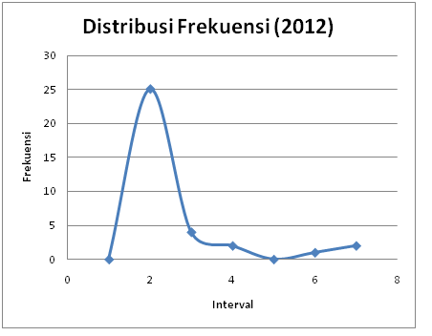

1. Frequency distribution graph of X-ray generator leakage data in 2012

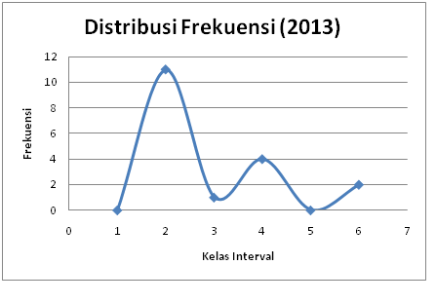

1. Frequency distribution graph of X-ray generator leakage data in 2013

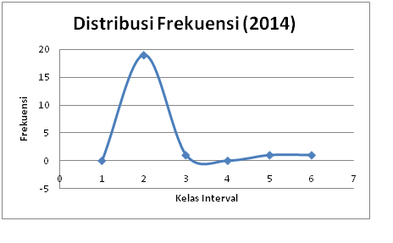

1. Frequency distribution graph of X-ray generator leakage data in 2014

Figures 11, 12 and 13, are the frequency distribution graph of X-ray generator leakage data in 2012, 2013, and 2014. The resulting data is in an abnormal distribution of chi-squared form. Therefore, in this research, a non-parametric statistical method is used to test the chi-square distribution using the Goodness of Fit Test.

Figures 14 to 22 are the frequency distribution graph of X-ray generator leakage data in each of the districts used as the sample in this research. The resulting data is in an abnormal distribution (chi-squared) form. Therefore, non-parametric statistical methods are used by testing the chi-square distribution using the Goodness of Fit Test.

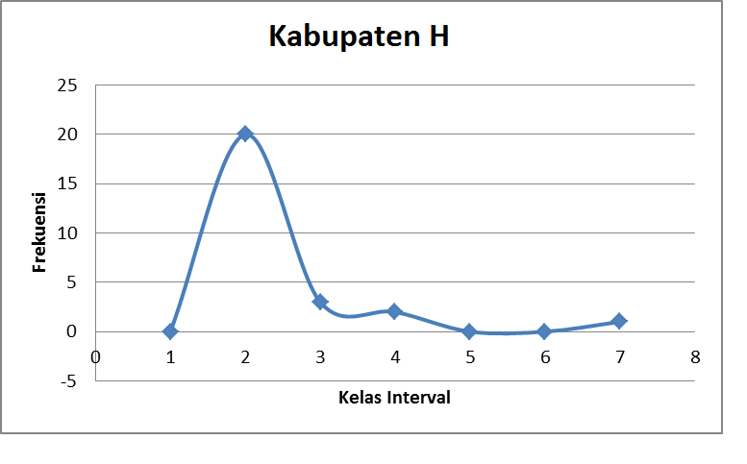

1. Frequency distribution graph of X-ray generator leakage data of district H

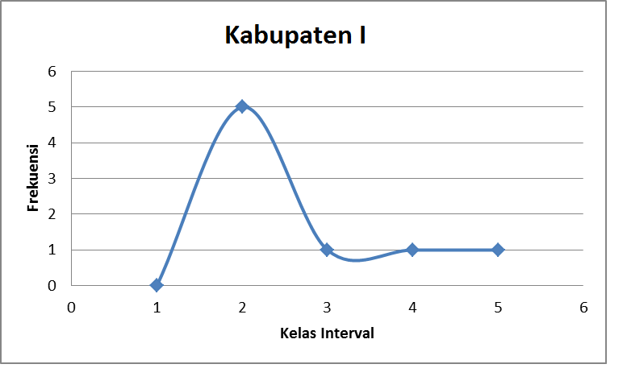

1. Frequency distribution graph of X-ray generator leakage data of district I

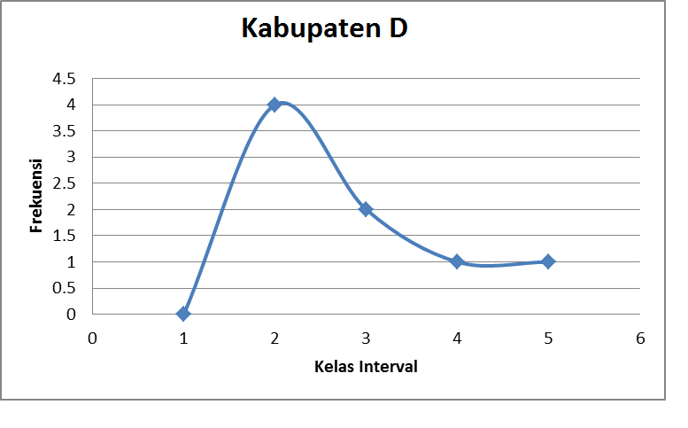

1. Frequency distribution graph of X-ray generator leakage data of district D

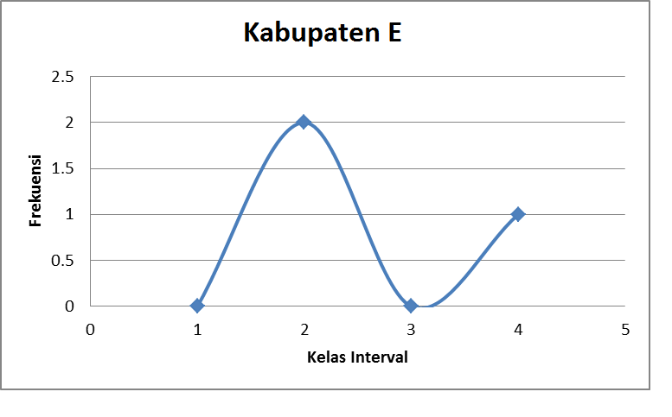

1. Frequency distribution graph of X-ray generator leakage data of district E

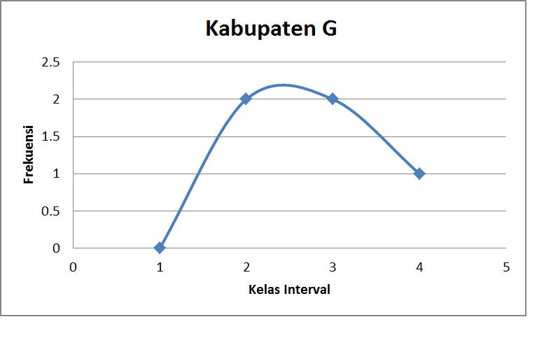

1. Frequency distribution graph of X-ray generator leakage data of district G

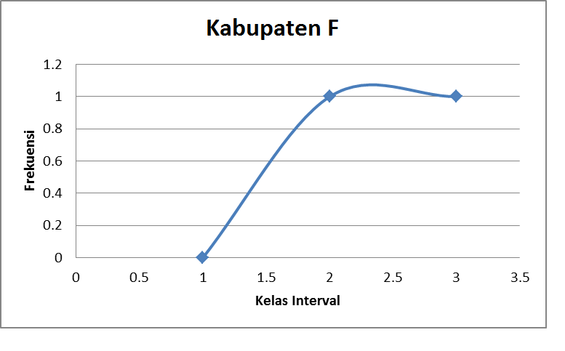

1. Frequency distribution graph of X-ray generator leakage data of district F

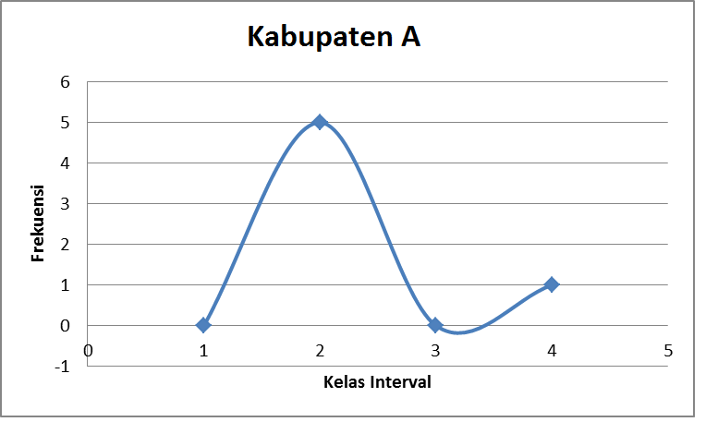

1. Frequency distribution graph of X-ray generator leakage data of district A

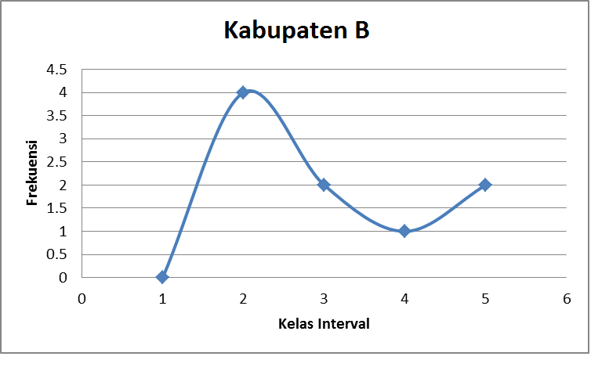

1. Frequency distribution graph of X-ray generator leakage data of district B

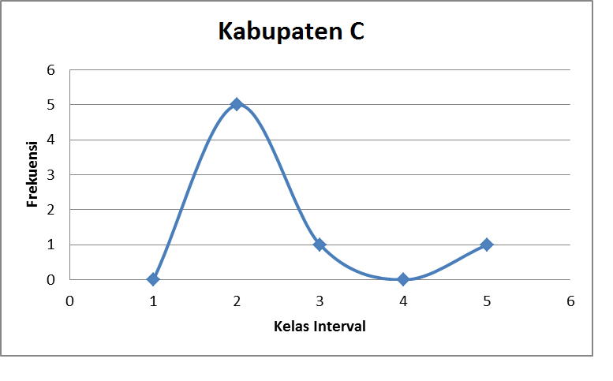

1. Frequency distribution graph of X-ray generator leakage data of district C

Calculation of the suitability test (Goodness of Fit Test)

In the calculation of this suitability test, $O_{i}$ is the observed frequency where the maximum X-ray generator leakage level is in mGy/hour, $n$ denotes the number of samples, p is the probability, and $E_{i}$ is the theoretical frequency. Table 1 is the compatibility test calculation result for $χ^{2}count$ of X-ray leakage data in 2012.

1. Calculation $χ^{2}count$ of X-ray generator leakage data in 2012



**then H0 is accepted**

The data on generator leakage at the radiology installations in Districts H and I in 2012 is the same. The value of $O_{i}$ indicates the maximum value for each X-ray generator in both districts is below the threshold value. This also shows that there are no differences in operating procedures and maintenance of X-ray generators at each radiology installation.

Table 2 is the calculation result of $χ^{2}count$ X-Ray Generator Leakage Data in 2013

1. Calculation $χ^{2}count$ of X-ray generator leakage data in 2013



**then H0 is accepted**

Based on the suitability test at the radiology installations of Districts D, E, G, and F in 2013, it can be concluded that the proportion of the leakage level is the same. The value of $O_{i}$ indicates the maximum leakage value for each X-ray generator is mostly below the threshold value based on the test method. This also shows no differences in operating procedures and maintenance of X-ray generators in each radiology installation in these districts.

Table 3 below is the result of the suitability test $χ^{2}count$ of X-ray Generator Leakage Data in 2014.

The X-ray generator radiation leakage data at the radiology installations of Districts A, B, and C in 2014are the same. The value of $O_{i}$ is maximum for each X-ray generator in Districts A, B, and C, which is mostly below the leakage threshold value. This also shows that there are no differences in operating procedures in these districts.

1. Calculation $χ^{2}count$ X-ray generator leakage data in 2014



**then H0 is accepted**

The suitability test of X-ray radiation leakage data at hospitals, health centers, and clinics in each district has the same proportion of X-ray generator leakage levels. Therefore, both are below the threshold value of 1 mGy/hour. It also shows no differences in the operating procedures and maintenance of X-ray generators installation in districts H, I, D, E, G, F, A, B, and C. This is because the operating procedures and generator maintenance have radiation leakage below safe limits. Meanwhile, the non-parametric statistics results using the Fit Test for X-ray generator leakage are shown in Table 4.

1. Non-parametric statistical results of the X-ray generator leakage data Fit test.

|  |  |  |  |
| --- | --- | --- | --- |
| District | Fit Test Value | Year | Fit Test Value |
| A | 2,31033<9,2364 | 2014 | 12,0193<29,6151 |
| B | 0,2944442<13,3616 |
| C | 4,6559925<10,6446 |
| D | 0,1884249<12,0170 | 2013 | 5,8046<24,7690 |
| E | 0,0576894<4,6052 |
| F | 0,4609793<2,70554 |
| G | 0,9539133<7,7794 |
| H | 17,452924<34,3816 | 2012 | 30,7035<43,72073 |
| I | 7,2867225<12,0170 |

Percentage calculation of X-ray generator leakage above the threshold in each district

The maximum data leakage on each generator in District H in 2012 showed two X-ray generators with leakage above the threshold of 1 mGy/hour, namely the OMNIX N-100 and Mednif F-100DC brands. The OMNIX Type N100 and Mednif F-100DC have the highest and maximum leakage values of 1,149 mGy/hour and 2,379 mGy/hour at the bottom position. Mad Leave F30-III in District C in 2014 also has the highest leakage at the bottom with a value of1.103 mGy/hour. This is due to the closeness of the collimator's closing position. The requirements for testing X-ray radiation leakage are by conducting a closed collimator with a maximum exposure of 1mGy/hour from the focal spot. Unclosed collimators can cause radiation more than the threshold from the direction of the collimator. Therefore, the OMNIX N100 and Mednif F-100DC X-ray generator tube containers with a downward direction need to be installed with lead (Pb) as a radiation barrier.

The maximum data in the district I in 2012 showed 3 X-ray generators with leakages above the threshold of 1 mGy/hour, namely the Hualun GPX-200C, Siemens 4801200, and Toshiba BLF-15B brands. The Hualun GPX-200C and Siemens 4801200 have the highest and maximum leakages with 2,765 mGy/hour values and 2.1506 mGy/hour in the right positions, respectively. Meanwhile, the Toshiba BLF-15B X has a maximum leakage of 1,025 mGy/hour in the left position. This is because the dimensions of the right or left X-ray generators, which denote the anode and cathode, have changed. Moreover, electron beam emission is made at the cathode. The collection of electrons that occurs on the surface of the filament causes electrons to buildup on the negative side with the inability to escape due to the attraction. The electrons are further accelerated to the anode. Excess radiation in the right or left position can be caused by changes in the dimensions of the X-ray generator, causing threshold leakage from the right or left position. The requirements for testing X-ray radiation leakage are by conducting a closed collimator with a maximum exposure of 1 mGy/hour at 1 meter from the focal spot. Therefore, the Hualun GPX-200C, Siemens 4801200, Toshiba BLF-15B X-ray tube case with the right and left directions to need to be installed with lead (Pb) as a radiation barrier.

CONCLUSION

The following conclusions were made in determining the feasibility of X-ray in analyzing radiation leakages at several districts in central Java province, initialized with A, B, C, D, E, F, G, H, and I from 2012-2014.

1. The average value of the highest radiation leakage of X-ray generators in these districts A, B, D, E, F, and G was below 1 mGy/hour. However, several X-ray generators in Districts H, I, and C exceeded the threshold with percentages of 7.6%, 37.5%, and 14.2%, respectively.
2. Thematic maps and window charts of X-ray generator radiation leakage levels are made easy to determine the condition in several districts in Central Java from 2012-2014.
3. The proportion of data from non-parametric statistical results of X-ray radiation leakage level is below 1 mGy/hour.

SUGGESTION

Based on the results, discussion, and conclusions, the following suggestions are proposed:

1. Future research needs to be conducted on the effect and position on the leakage value of X-ray generators.
2. Additional data is needed in the X-ray generator leakage testing process, such as the frequency of use and lifetime.
3. Radiation workers in all radiology installations always need to implement the principle of radiation protection. Education is also required by providing maintenance materials, for example, installing lead on the side or making repairs to the X-ray generator that exceeds the threshold value.

REFERENCES

1. BAPETEN, 2014, Peraturan Kepala BAPETEN No.15 tentang Keselamatan Radiasi Dalam Penggunaan Pesawat Sinar-X Radiologi Diagnostik dan Intervensional, Jakarta.
2. Wardhana, 2007, *Teknologi Nuklir Proteksi Radiasi dan Aplikasinya*, Penerbit Andi, Yogyakarta
3. Bushong Stewart, 1993, *Radiologic Science for Technologists*, Baylor College Texas, USA.
4. Wiharja, U., and Al Bahar, A. K., 2019, Analisa Uji Kesesuaian Pesawat Sinar-X Radiografi, *Prosiding Semnastek*.
5. Budiyanto, Eko, 2004, *Sistem Informasi Geografis Menggunakan ArcView GIS*, Andi, Yogyakarta.
6. Yousefi, M., Mesbahi, F., Abbasi, I., Kousha, M., and Rahmani, K., 2020, “Application of Geographical Information System in Analysis and Detection Of Microbial Contamination In Water Supply Network,” *Journal of Health Sciences & Surveillance System*, vol. 8, no. 3, pp. 110-114.
7. Harahap, R. R., Parinduri, I., Hutagalung, S. N., Saleh, K., and Fachri, B., 2020. *Pembelajaran Sistem Informasi Geografis Menggunakan ArcView 3.3*. Yayasan Kita Menulis.
8. Martono, 2008, *Penggambaran Peta Tematik Menggunakan Sistem Informasi Geografis dengan Perangkat Lunak ArcView 3.3*, UMS, Surakarta.
9. Hayati, Rahma, 2007, “Aplikasi Peta Tematik Lokasi dan Wakto Tempuh bagi Pelaku Jasa Wisata di Kompleks Candi Gedong Songo Kabupaten,” *Jurnal Geografi ISSN 2085-191X*, vol. 4, no.2, UNS, Semarang.
10. Pasaribu, H. R., and Daniati, S. E., 2020, “Gambaran Pemetaan Penyakit Menular Dan Tidak Menular Pasien Peserta BPJS Menggunakan Aplikasi Arcview Gis 3.3 Di Puskesmas Melur Tahun 2020,” *JHMHS: Journal of Hospital Management and Health Science*, vol. 1, no. 02, pp. 67-78.
11. Susetyo, Budi, 2010, *Statistika Untuk Analisis Data Penelitian,* Refika Aditama, Bandung.
12. Rodriguez, A., Pino, G., and Herrera, R., 2020, “A Non-Parametric Statistic For Testing Conditional Heteroscedasticity For Unobserved Component Models,” *Journal of Applied Statistics*, pp. 1-27.
13. Santoso, S., 2019, *Mahir statistik parametrik,* Elex Media Komputindo, Jakarta.
14. Fauzy, 2011, *Statistik Nonparametrik,* Ardana Media, Yogyakarta.