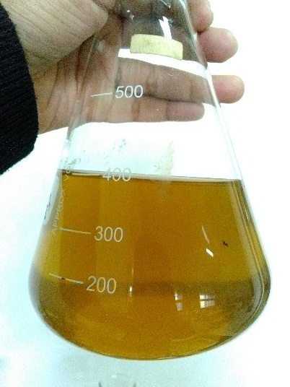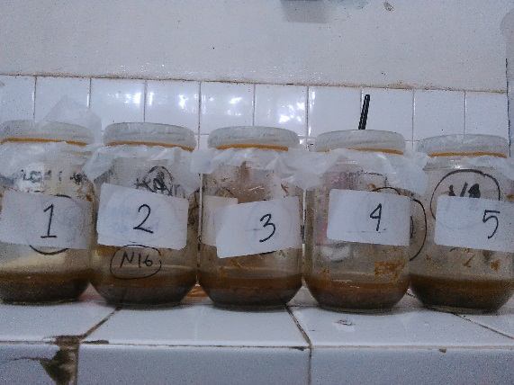Ektrak enzim selulase kasar Hidrolisis enzimatik)

**Lampiran 1.** Dokumentasi Penelitian

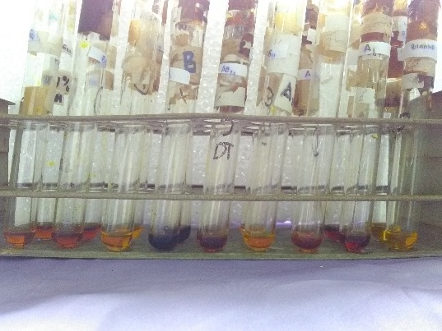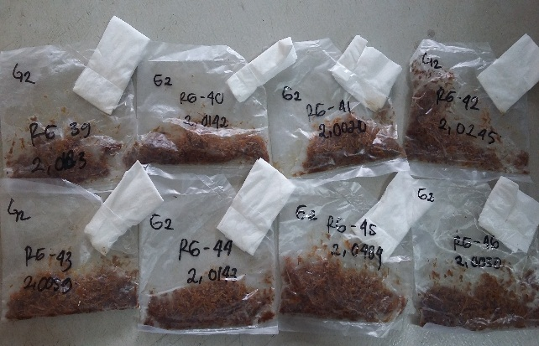

Fermentasi Padat (SSF) Uji aktivitas enzim selulase

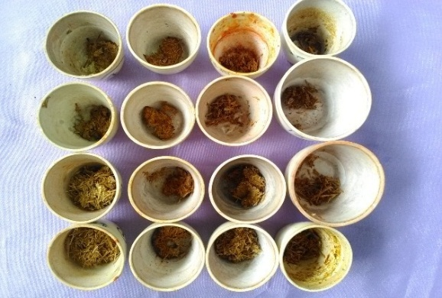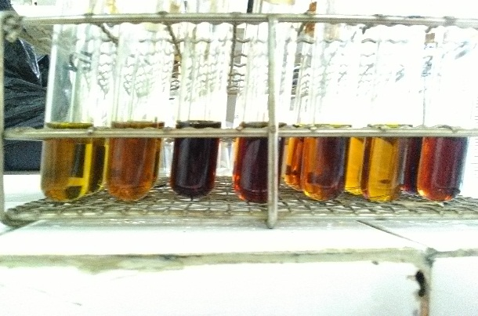

Uji kadar glukosa Uji kadar air

Inkbator (Heraeus) Inkubator (Adam Air Baths)



pH meter (Pcstestr 35) Autoklaf (Wiseclave)

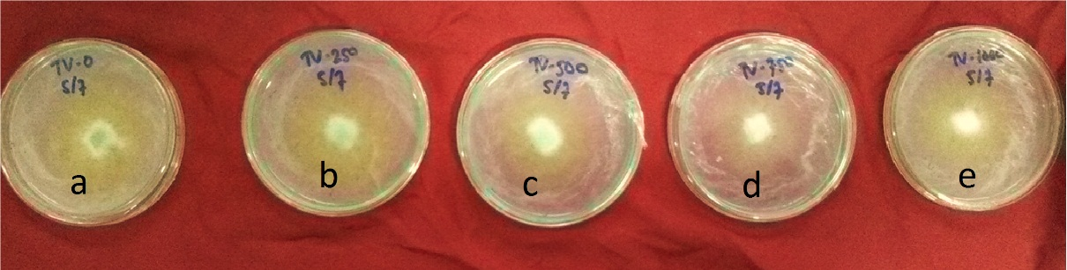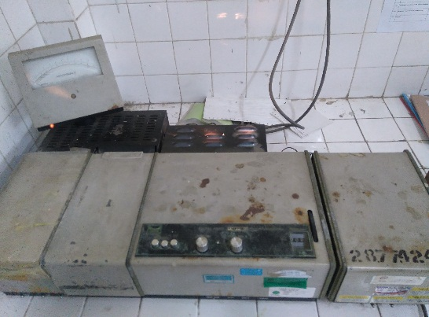

Spektrofotometer UV-Vis *Trichoderma viride* dalam PDA

**Lampiran 2.** Data Uji Statistik IBM SPSS 20.0

1. Aktivitas selulase kapang *Trichoderma viride*

**ANOVA**

VAR00006

|  |  |  |  |  |  |
| --- | --- | --- | --- | --- | --- |
|  | Sum of Squares | df | Mean Square | F | Sig. |
| Between Groups | 7.406 | 4 | 1.852 | 36.625 | .001 |
| Within Groups | .253 | 5 | .051 |  |  |
| Total | 7.659 | 9 |  |  |  |

**VAR00006**

Duncan

|  |  |  |  |  |
| --- | --- | --- | --- | --- |
| BB | N | Subset for alpha = .05 | | |
| 1 | 2 | 3 |
| 0 | 2 | 1.4570 |  |  |
| 250 | 2 | 1.8050 |  |  |
| 750 | 2 |  | 3.0395 |  |
| 1000 | 2 |  | 3.1345 |  |
| 500 | 2 |  |  | 3.7365 |
| Sig. |  | .182 | .690 | 1.000 |

Means for groups in homogeneous subsets are displayed.

a Uses Harmonic Mean Sample Size = 2.000.

1. Perlakuan awal pada substrat jrami padi dengan pH berbeda pada 72 jam setelah inokulasi

**ANOVA**

VAR00006

|  |  |  |  |  |  |
| --- | --- | --- | --- | --- | --- |
|  | Sum of Squares | df | Mean Square | F | Sig. |
| Between Groups | 5.327 | 4 | 1.332 | 22.529 | .002 |
| Within Groups | .296 | 5 | .059 |  |  |
| Total | 5.623 | 9 |  |  |  |

**VAR00006**

Duncan

|  |  |  |  |
| --- | --- | --- | --- |
| BB | N | Subset for alpha = .05 | |
| 1 | 2 |
| pH 7 | 2 | 7.5705 |  |
| pH 8 | 2 | 7.9915 |  |
| pH 4 | 2 |  | 9.0240 |
| pH 6 | 2 |  | 9.3300 |
| pH 5 | 2 |  | 9.3300 |
| Sig. |  | .144 | .275 |

Means for groups in homogeneous subsets are displayed.

a Uses Harmonic Mean Sample Size = 2.000.

1. Pengaruh perlakuan awal substrat dengan NaOH terhadap hidrolisis selulosa (inokulasi 72 jam)

**ANOVA**

VAR00006

|  |  |  |  |  |  |
| --- | --- | --- | --- | --- | --- |
|  | Sum of Squares | df | Mean Square | F | Sig. |
| Between Groups | 4.521 | 4 | 1.130 | 38.605 | .001 |
| Within Groups | .146 | 5 | .029 |  |  |
| Total | 4.667 | 9 |  |  |  |

**VAR00006**

Duncan

|  |  |  |  |  |
| --- | --- | --- | --- | --- |
| BB | N | Subset for alpha = .05 | | |
| 1 | 2 | 3 |
| 4% | 2 | 6.1945 |  |  |
| 0% | 2 | 6.5005 |  |  |
| 1% | 2 |  | 7.4560 |  |
| 2% | 2 |  | 7.6470 | 7.6470 |
| 3% | 2 |  |  | 7.9150 |
| Sig. |  | .134 | .315 | .178 |

Means for groups in homogeneous subsets are displayed.

a Uses Harmonic Mean Sample Size = 2.000.

1. Hidrolisis selulosa substrat jerami padi

VAR00006

|  |  |  |  |  |  |
| --- | --- | --- | --- | --- | --- |
|  | Sum of Squares | df | Mean Square | F | Sig. |
| Between Groups | 288.097 | 5 | 57.619 | 29.213 | .000 |
| Within Groups | 19.724 | 10 | 1.972 |  |  |
| Total | 307.821 | 15 |  |  |  |

**VAR00006**

Duncan

|  |  |  |  |  |  |
| --- | --- | --- | --- | --- | --- |
| BB | N | Subset for alpha = .05 | | | |
| 1 | 2 | 3 | 4 |
| E-G0 | 2 | 5.1945 |  |  |  |
| F-G0 | 3 |  | 10.3603 |  |  |
| F-G1 | 2 |  | 10.8770 |  |  |
| E-G1 | 3 |  |  | 14.3433 |  |
| F-G2 | 3 |  |  | 15.2787 |  |
| E-G2 | 3 |  |  |  | 19.2053 |
| Sig. |  | 1.000 | .685 | .468 | 1.000 |

Means for groups in homogeneous subsets are displayed.

a Uses Harmonic Mean Sample Size = 2.571.

b The group sizes are unequal. The harmonic mean of the group sizes is used. Type I error levels are not guaranteed.

1. Hidrolisis selulosa substrat batang rumput gajah

VAR00006

|  |  |  |  |  |  |
| --- | --- | --- | --- | --- | --- |
|  | Sum of Squares | df | Mean Square | F | Sig. |
| Between Groups | 193.130 | 5 | 38.626 | 55.507 | .000 |
| Within Groups | 5.567 | 8 | .696 |  |  |
| Total | 198.697 | 13 |  |  |  |

**VAR00006**

Duncan

|  |  |  |  |  |  |
| --- | --- | --- | --- | --- | --- |
| BB | N | Subset for alpha = .05 | | | |
| 1 | 2 | 3 | 4 |
| E-G0 | 2 | 1.5485 |  |  |  |
| F-G1 | 2 |  | 4.0355 |  |  |
| E-G1 | 3 |  |  | 9.3353 |  |
| F-G1 | 2 |  |  | 9.5925 |  |
| E-G2 | 3 |  |  |  | 11.4907 |
| F-G2 | 2 |  |  |  | 12.0775 |
| Sig. |  | 1.000 | 1.000 | .752 | .477 |

Means for groups in homogeneous subsets are displayed.

a Uses Harmonic Mean Sample Size = 2.250.

b The group sizes are unequal. The harmonic mean of the group sizes is used. Type I error levels are not guaranteed.

1. Kadar glukosa substrat jerami padi

**ANOVA**

VAR00006

|  |  |  |  |  |  |
| --- | --- | --- | --- | --- | --- |
|  | Sum of Squares | df | Mean Square | F | Sig. |
| Between Groups | 4172.409 | 8 | 521.551 | 51.728 | .000 |
| Within Groups | 131.073 | 13 | 10.083 |  |  |
| Total | 4303.482 | 21 |  |  |  |

**VAR00006**

Duncan

|  |  |  |  |  |  |  |
| --- | --- | --- | --- | --- | --- | --- |
| BB | N | Subset for alpha = .05 | | | | |
| 1 | 2 | 3 | 4 | 5 |
| K-G0 | 2 | 4.9745 |  |  |  |  |
| K-G1 | 2 | 9.6310 | 9.6310 |  |  |  |
| E-G0 | 2 |  | 12.8565 |  |  |  |
| K-G2 | 2 |  | 13.2600 |  |  |  |
| F-G0 | 3 |  |  | 25.6417 |  |  |
| F-G1 | 2 |  |  | 26.9200 |  |  |
| E-G1 | 3 |  |  |  | 35.4990 |  |
| F-G2 | 3 |  |  |  | 37.8143 |  |
| E-G2 | 3 |  |  |  |  | 47.5337 |
| Sig. |  | .136 | .260 | .670 | .444 | 1.000 |

Means for groups in homogeneous subsets are displayed.

a Uses Harmonic Mean Sample Size = 2.348.

b The group sizes are unequal. The harmonic mean of the group sizes is used. Type I error levels are not guaranteed.

1. Kadar glukosa substrat batang rumput gajah

**ANOVA**

VAR00006

|  |  |  |  |  |  |
| --- | --- | --- | --- | --- | --- |
|  | Sum of Squares | df | Mean Square | F | Sig. |
| Between Groups | 7780.281 | 8 | 972.535 | 91.108 | .000 |
| Within Groups | 117.420 | 11 | 10.675 |  |  |
| Total | 7897.702 | 19 |  |  |  |

**VAR00006**

Duncan

|  |  |  |  |  |  |
| --- | --- | --- | --- | --- | --- |
| BB | N | Subset for alpha = .05 | | | |
| 1 | 2 | 3 | 4 |
| K-G0 | 2 | 3.6690 |  |  |  |
| E-G0 | 2 | 6.9775 |  |  |  |
| K-G1 | 2 | 7.9455 |  |  |  |
| K-G2 | 2 | 11.0520 |  |  |  |
| F-G0 | 2 |  | 18.1850 |  |  |
| E-G1 | 3 |  |  | 42.0633 |  |
| F-G1 | 2 |  |  | 43.2215 |  |
| E-G2 | 3 |  |  |  | 51.7757 |
| F-G2 | 2 |  |  |  | 54.4205 |
| Sig. |  | .051 | 1.000 | .720 | .418 |

Means for groups in homogeneous subsets are displayed.

a Uses Harmonic Mean Sample Size = 2.160.

b The group sizes are unequal. The harmonic mean of the group sizes is used. Type I error levels are not guaranteed.